Journal of Mathematical Sociology, 28: 261*7*295, 2004 Copyright *#* Taylor & Francis Inc.

ISSN: 0022-250X print/1545-5874 online DOI: 10.1080*=*00222500490516699

# STATUS DIFFERENTIATION AND THE COHESION OF SOCIAL NETWORKS

*Matthew S. Bothner, Toby E. Stuart, and Harrison C. White University of Chicago*

*Columbia University*

*This article examines the effects of status differentiation on the cohesion of a social structure. Using a formal model, we simulate the fates of a hypothetical cohort of newly hired employees, who are equals in the eyes of their boss and in the nascent stages of sorting into a status hierarchy. We cast these employees in a process in which they exert effort, receive public approval from the boss in exchange, and thus come to fill different places in a status order. We then consider the circumstances under which these workers cohere as a group and when, by contrast, differentiation makes cohesion among them unlikely. Our results show that the extent of the boss’s autonomy in relationship to employees accounts for this difference in outcomes. Under an autonomous boss, as dif- ferentiation transpires, status-based social forces break the group of workers apart. Conversely, when the boss occupies a compromised position, group-level cohesion coexists with differentiation. Our main contribution is the intuition that the cohesion-related consequences of status differentiation can sub- stantially depend on the tie between contestants and their external audience. We conclude by developing conjectures for empirical research consistent with our main findings.*

*Keywords: Status, Cohesion, Inequality, Sociology of markets*

# INTRODUCTION

How does status differentiation affect cohesion? What conditions encou- rage actors to remain integrated even as they progressively differ in the functions they perform and the levels of status they achieve? Interest in this question dates back to the foundations of sociological theory. Durkheim (1933, 1893), for instance, argued that a set of widely diffused

Direct correspondence to Matthew Bothner, University of Chicago, Graduate School of Business, 1101 E. 58th Street, Chicago, IL 60637, [matthew.bothner@gsb.uchicago.edu](mailto:matthew.bothner@gsb.uchicago.edu) 773-834-5953. We thank Ronald Burt, Jeong-han Kang, Wonjae Lee, and Damon Phillips for useful comments. This work is supported by the Charles E. Merrill Faculty Research Fund at the University of Chicago Graduate School of Business.

261

beliefs and values is essential for preserving cohesion among occupants of differentiated social structures. Since then many have noted how rarely cohesive ties actually exist among those who differ in status, as well as the importance of shared cultural traits or experiences among differ- entiated actors if they are to remain connected. The conflict between differentiation and cohesion is illustrated by Berger’s (1993) insight that status-different members of a voluntary organization will sit together but will not socialize outside the group. Similar findings are reported throughout the organizational sociology literature, such as in Kanter (1977) and Podolny (1993). It is thus well understood that status-based social forces often threaten to break the ties between increasingly dif- ferentiated members of a group, thus putting at risk the survival of the collectivity.

We extend existing research on status and cohesion by proposing a for- mal model that specifies the conditions under which the process of status differentiation between actors precludes cohesion among them and when, conversely, cohesion endures despite the increasing salience of status dif- ferences between group members. Consistent with earlier work, which has traced the likelihood that social actors form a tie to their similarity on a salient dimension (Lazarsfeld and Merton, 1954; Rogers and Kincaid, 1981), we consider a social structure cohesive insofar as its members proceed on parallel pathways as status differentiation unfolds.

Examining the link between differentiation and cohesion is important because status differences arise in groups of all types (e.g., for adolescent cliques, Sherif et al., 1955; for street gangs, Whyte, 1943; for bomber crews, Torrance, 1954; in laboratory task groups, the literature begins with Bales, 1950; for formal models, see Horvath, 1965; Skvoretz, 1981, 1988), and because differences in status likely make it harder to obtain the perfor- mance-related advantages of cohesion. Specifically, members of a cohesive group potentially enjoy many benefits, such as higher motivation (Coleman, 1988; 1990), fewer barriers to interpreting, transferring, and appropriating the value of information (Baker, 1984; Burt, 2001, 2002), as well as a higher level of trust and resulting willingness to cooperate (Kanter, 1977; Granovetter, 1985). Considering the close link between tie strength and similarity on a visible dimension, we think that, at least in certain contexts, escalating differences in status are likely to interfere with the maintenance of cohesion. We therefore aim to distinguish such contexts from those in which cohesion is more likely to persist.

Using a formal model of markets (White, 1981, 2002), we move toward that goal by considering a hypothetical cohort of newly hired employees, who are virtually equals in the eyes of their boss and in the nascent stages of sorting into a status hierarchy. We cast these employees in a process in which they exert effort, get public approval from the boss in exchange, and

thus come to fill different places in a status order. We then bring into focus the circumstances under which these workers cohere as a group and when, by contrast, differentiation makes cohesion among them unlikely.

Our results show that the extent of the boss’s autonomy or bargaining power (e.g., Coser, 1975; Pfeffer and Salancik, 1978; Burt, 1980) vis-a`-vis her employees accounts for this difference in outcomes. Under an auto- nomous boss, as differentiation transpires, status-based social forces break the group of workers apart. Conversely, when the boss occupies a com- promised position, group-level cohesion coexists with differentiation. Our main contribution is the formal result that the cohesion-related con- sequences of status differentiation depend substantially on the tie between contestants and their external audience (such as a boss, buyer, critic, or patron). We do not account for differences in outcomes by turning to variations in group composition. On the contrary, in our model it is a condition external to the group that contours the group’s fate, determining whether or not internal cohesion can last.

Although we later depict the dependence of cohesion on autonomy analytically, the intuition behind our model is as follows: Under a weakly autonomous boss, *all* employees (even those of low status) are suffi- ciently well positioned to extract greater rewards from the boss with time. Under an autonomous boss, however, *only* higher status employees are able to proceed on a positive trajectory; those of lower status (no longer sheltered by their collective bargaining power) now trend downward instead, and the different trajectories of workers’ rewards undermines the cohesion of the group. Therefore, the balance of power between an eva- luator and his or her subordinates affects the significance (or insignif- icance) of occupying roles of marginal status and thus governs the time- dependent cohesion (or dissolution) among those differentially located in the distribution. In this sense, there is an intuitive link between a group’s vertical power and where in the status distribution a threshold appears, on either side of which the time-varying fates of its members diverge. When the group’s position is strong (the boss’s is weak), this threshold effec- tively falls beneath the minimum level of status, thereby allowing the group to cohere. When the group’s position is weak (the boss’s is strong), the dividing line rises and the evolving fates of low and high status actors then differ.

We turn next to the specifics of the model, which will allow us to observe the contingent effects of status differentiation among newly hired employees. We proceed as parsimoniously as we can, specifying only a few main assumptions about the boss and her employees. Section 2 presents the main features of our model, after which we discuss our measure of cohesion in section 3 and findings in section 4. In section 5, we conclude by developing conjectures for empirical research consistent with our findings.

# THE ELEMENTS OF THE MODEL

## The Boss

The model consists of a boss and three workers. Although at first the boss observes no quality differences among her employees, distinctions in quality surface as soon as they start producing. Using data on employees’ pro- ductivity, the boss updates her view of each of them, an event that launches an evolving status hierarchy. We assume that a feedback loop operates as follows: The quality of each worker governs his initial productivity (and rewards), which then affects his perceived quality or status (Podolny, 1993), which in turn contours his future productivity (and rewards), again updating the boss’s perceptions, and so the cycle goes on. Therefore, each employee’s fixed endowment of quality yields a time-varying level of status, which decouples more or less from the quality endowment with time. The upshot of this process is that the boss’s evaluations elicit a cycle in which the most able worker in time delivers a disproportionate amount of utility, which is also greater than his ability would predict.

The boss judges employees’ productivity (the input for rewards) according to the following utility schedule:

*U* ð*y*; *n*Þ¼ *ryanb* ð1Þ

where *U* ð*y*; *n*Þ is the utility the boss derives from *y* units of productivity by an employee of quality *n*. While *y* could have many empirical referents, we equate *y* to effort, the amount of time an employee works during an interval in which the boss appraises the value of his contribution. The entries in the quality vector *n* range from 1 to 2, and correspond to differences in ability or experience relevant to the boss’s aims. Within *n* there are as many elements as there are workers in the network.

Moving to the other side of Equation (1), *r* is a scalar referring to the attractiveness of all employees as a set. Were *r* to rise, the boss would find the cohort of workers more attractive collectively. Shaping returns to scale is the exponent *a*. When *a* < 1, for example, utility per unit falls with the time employees invest in the workplace, so that they face diminishing returns to effort.

We use *b* to depict the level of status differentiation, which rises with time. Were *b* equal to zero, the Cobb7Douglas interaction in Equation (1) would drop out, denoting the boss’s full innocence of differences in quality. Consequently, when *b* is very low, the workgroup (however briefly) lacks a pecking order (Chase, 1980) and a correlative system of roles (Nadel, 1957; White, 1963), and thereby for the moment mirrors a context in which strangers with no prior social contact deal with each other for the first time (Berger and Luckmann, 1966).

We follow several precedents by viewing this egalitarian state as tem- porary, and soon to be followed by a progressively more skewed status order (Bales, 1950). Social systems have shown themselves resistant to equality, conforming instead to an ‘‘iron law of oligarchy’’ (see, e.g., Mayhew and Levinger, 1976). Evolving differences between perceived quality or status *nb* and quality *n* allow us to speak of an emergent status hierarchy and examine its effects on the cohesion of the workgroup as a whole. We specify the unfolding differentiation captured by *b* in Equation

(1) so that current ratio of the highest quality employee’s status to that of his lowest quality rival equals the ratio of their utilities at time *t*-1:1

*n*max *b*

� l

*n*min

¼ *U* ð*y*; *n*maxÞ*t*-1

*U* ð*y*; *n*minÞ*t*-1

ð2Þ

We further assume that the boss gets an equivalent ‘‘deal’’ from all employees whenever they produce and receive approval. Without equiva- lent exchanges, we posit that differentiation would be unsustainable, for the boss would then cede all approval to the employee who offers the best deal. So, although the boss rewards levels of effort that differ in magnitude, and that yield different amounts of utility, she still gets the same degree of utility or satisfaction for every unit of approval she bestows. We designate this ratio y, which is a constant ratio of utility *U* to *W*, where *W* signifies the intangible rewards conveyed by the boss.2

y ¼ *U* ð*y*; *n*Þ

*W* ð*y*; *n*Þ

ð3Þ

The value of y results mainly from the boss’s autonomy in relation to her employees. Various scholars have conceived of autonomy (or bargaining power) as a social actor’s absence of dependence on a particular set of others (Emerson, 1962; Pfeffer and Salancik, 1978; Burt, 1980; Phillips, 2001). While empirical examples of autonomy are many, an apposite case of high autonomy is one where the boss can easily outsource the tasks per- formed by current employees to others, or has already set up a ‘‘dual form’’ (Bradach and Eccles, 1989), in which she relies partly on in-house employees, and partly on those outside the firm. When the boss has many ways of reaching her production-related aims, pressure to mete out intangible rewards to her employees is lower. Conversely, an example of a

1We thus assume that *n*max is fixed at 2 and that *n*min is fixed at 1 and, by extension, that quality represents a stable trait, not an endowment capable of growth as an employee learns. 2In this sense, the assumption of a constant ratio of utility *U* to rewards *W* is not only con- sistent substantively with the sustainability of differentiation. Constancy also makes more tractable the task of letting the parameters affecting *U*, shown in equation (1), shape *W*, which

we begin deriving in Equation (9).

low-autonomy boss is one facing workers with many external options (as was the situation enjoyed by information technology specialists at the height of the internet era, for instance). Correspondingly, in our model, when the boss’s autonomy is low, she conveys more approval to employees in aggregate than their collective utility would predict. And when the boss’s autonomy is high, she offers them less approval overall than would be expected given the utility they jointly provide.

We represent the effect of the boss’s autonomy (which in turn affects effort and approval, as we will show), by the parameter g. Gamma dilates or contracts the sum of the employee-level utilities:

g

"X

#

V ¼ *U* ð*y*; *n*Þ

*n*

ð4Þ

We portray low autonomy on the part of the boss by g > 1, and high autonomy on her part by g < 1.

We also assume that total approval employees receive from the boss equals the sum of each utility raised to gamma:

g

"X

#

V ¼ *U* ð*y*; *n*Þ ¼

*n*

*W* ð*y*; *n*Þ ¼ W ð5Þ

*n*

X

This identity allows us to write y, the ratio of utility *U* to approval *W*, as a function of gamma. Conceptually, the reliance of y on g implies that the experience of the boss when allocating intangibles results from her level of autonomy in the workplace. Consider, for instance, the level of pleasure (or consternation) that a leader enjoys (or endures) when rewarding sub- ordinates on whom she depends minimally (or substantially). When the boss is highly dependent, it is easy to imagine that her micro-level experience during each act of dispensing intangibles reflects her low level of autonomy with respect to her employees at a macro-level.

Although we must formally state further assumptions among employ- ees before deriving the link between y, the ratio of utility to approval, and g, the absence of the boss’s autonomy or bargaining power with respect to employees, for now we can depict a ‘‘break-even’’ value of theta y0 by using Equations (3) and (5), such that the sum of *U* over *n* raised to gamma equals the total flow of approval:

so that:

0

g

V ¼ *U* ð*y*; *n*Þ

"X

#

*n*

¼ "y0

g

*W* ð*y*; *n*Þ

X

#

*n*

¼ yg Wg ¼ W ð6Þ

y0 ¼ Wð1-gÞ=g ð7Þ

## Employees

Shifting to employee-related premises, from which we will derive *y*0 and other main outcomes, we assume first that employees monitor (through direct observation) each other’s productivity *y* and the approval *W*( *y*) they receive. In our model, they do so to reduce uncertainty about the boss’s preferences and thus select a level of effort that maximizes the difference between their costs and rewards. We thus follow other sociological inter- pretations of market-related conduct in which actors lower uncertainty about future events by gleaning information from rivals’ prior transactions (e.g., Podolny, 1994; Stuart, 1998).

We assume that employees are seekers of intangible rewards (approval), following a decades-old stream of research in organization studies. Much of the classical work on this topic falls within the ‘‘natural systems’’ view of organizations (Scott, 1992, pp. 51*7*75), whose proponents considered non- pecuniary rewards to be powerful motivators. In an early work, Barnard (1938) argued that nonmaterial rewards, such as distinction or prestige, were often more important than financial incentives for the task of growing commercial organizations. The motivational benefits of the mere attention of prominent observers then became particularly salient for organizational scholars after the Hawthorne studies, which documented that workers exerted more effort simply because they had been singled out for experi- mental research (Mayo, 1945). Subsequently, as exchange theory took shape, Homans (1961), too, portrayed people as being driven by the pursuit of approval.

Approval is also a powerful motivator because it is fungible. When enough prestige has flowed to a social actor, he or she may then convert that stock into other resources, such as informal influence (Mills, 1956; Goode, 1978; Taylor, 1978). Thus, both because of a general human desire for approval and because approval is an exchangeable social good, we assume employees to be approval seekers. Consistent with our model, it is easy to imagine new employees trading effort for approval, which both offers short-run satisfaction and long-run worth as a currency for exchange. We show a hypothetical approval schedule for three employees in Figure1, where approval *W*( *y*) is on the vertical axis and effort *y* is on the

horizontal.

We assume that employees use this sort of function to make decisions about the effort they should put forth in future rounds in which the boss evaluates them. The approval schedule offers a collection of possibilities based on recent levels of effort, which the boss has rewarded and which employees have observed. Although we make many simplifying assump- tions (such as signifying effort by a scalar), we think that our claim that contestants choose a level of effort by collectively making sense of the fates

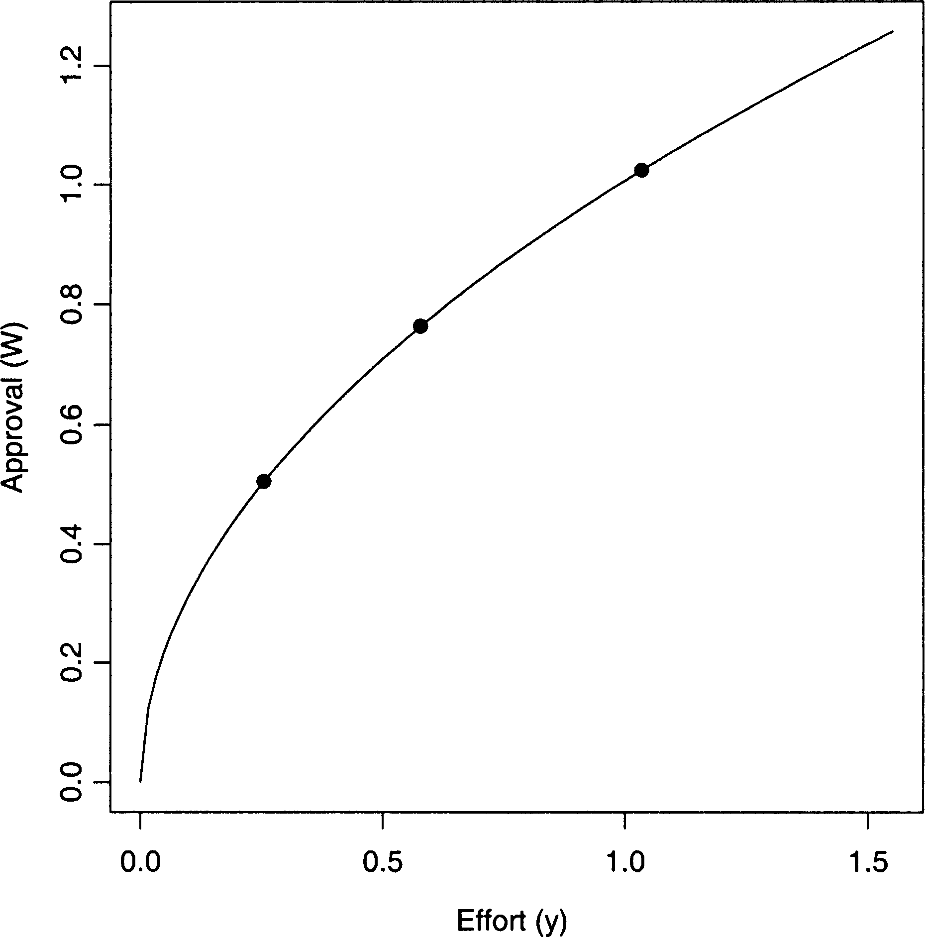

FIGURE 1 The relationship between effort *y* and the approval employees receive in exchange for their effort *W*( *y*). The effort levels and rewards for three hy- pothetical employees are depicted along the approval schedule. Their entries in the quality vector *n* are 1, 1.5, and 2.

of others reasonably represents a main facet of competitive systems in which the volume of production figures as the central choice variable.

We also assume that employees know their cost schedules and, along with the profile of (*y,W*( *y*)) pairs, the effort level *y* that will yield the highest profit. We depict the cost schedule as follows:

*C*ð*y*; *n*Þ¼ *qycnd* ð8Þ

*C*( *y*; *n*) is the cost of producing at level *y* for an employee of quality *n*. The constant *q*—the analogue of *r* in Equation (1)—reflects across-the-board costs. For instance, *q* would rise if working conditions became increasingly arduous due to relocation or the need to replace an important client. When *c* > 1, employees face diseconomies of scale; for *c* < 1, they face economies; and for unity, constant returns. And as long as *d* ¼6 0, the entries in *n* are coefficients that introduce distinctions in marginal cost. Such variations derive from differences in underlying levels of aptitude for the demands of the job.

We follow Spence (1974) in assuming that higher quality employees find it easier to deliver a given level of output. Spence modeled wages as a function of years of education, which prospective employees finished

before the firm chose whether to hire them. Conversely, we consider the effort employees exert once inside the firm. Nevertheless, just as Spence’s more talented (prospective) employees complete education at lower cost (thus letting years of education signal their unobserved quality), our highest quality employee has the shallowest cost schedule. In other words, we assume *d* < 0.

We illustrate this inverse cost-quality relationship by adding cost curves, *C*( *y*; *n*), to our first plot of rewards against productivity, which we depict in Figure 2. We make this assumption because of our overarching claim that initially undetectable differences in ability quickly give rise to distinctions in status that in turn affect group-level cohesion. The higher productivity (and rewards) of the most able employee in Figure 2 reflects this. With that employee’s higher rewards comes a greater divide between him and his rivals in the status hierarchy, a further monopolization of rewards by the top contestant, more variance in status, and so on.

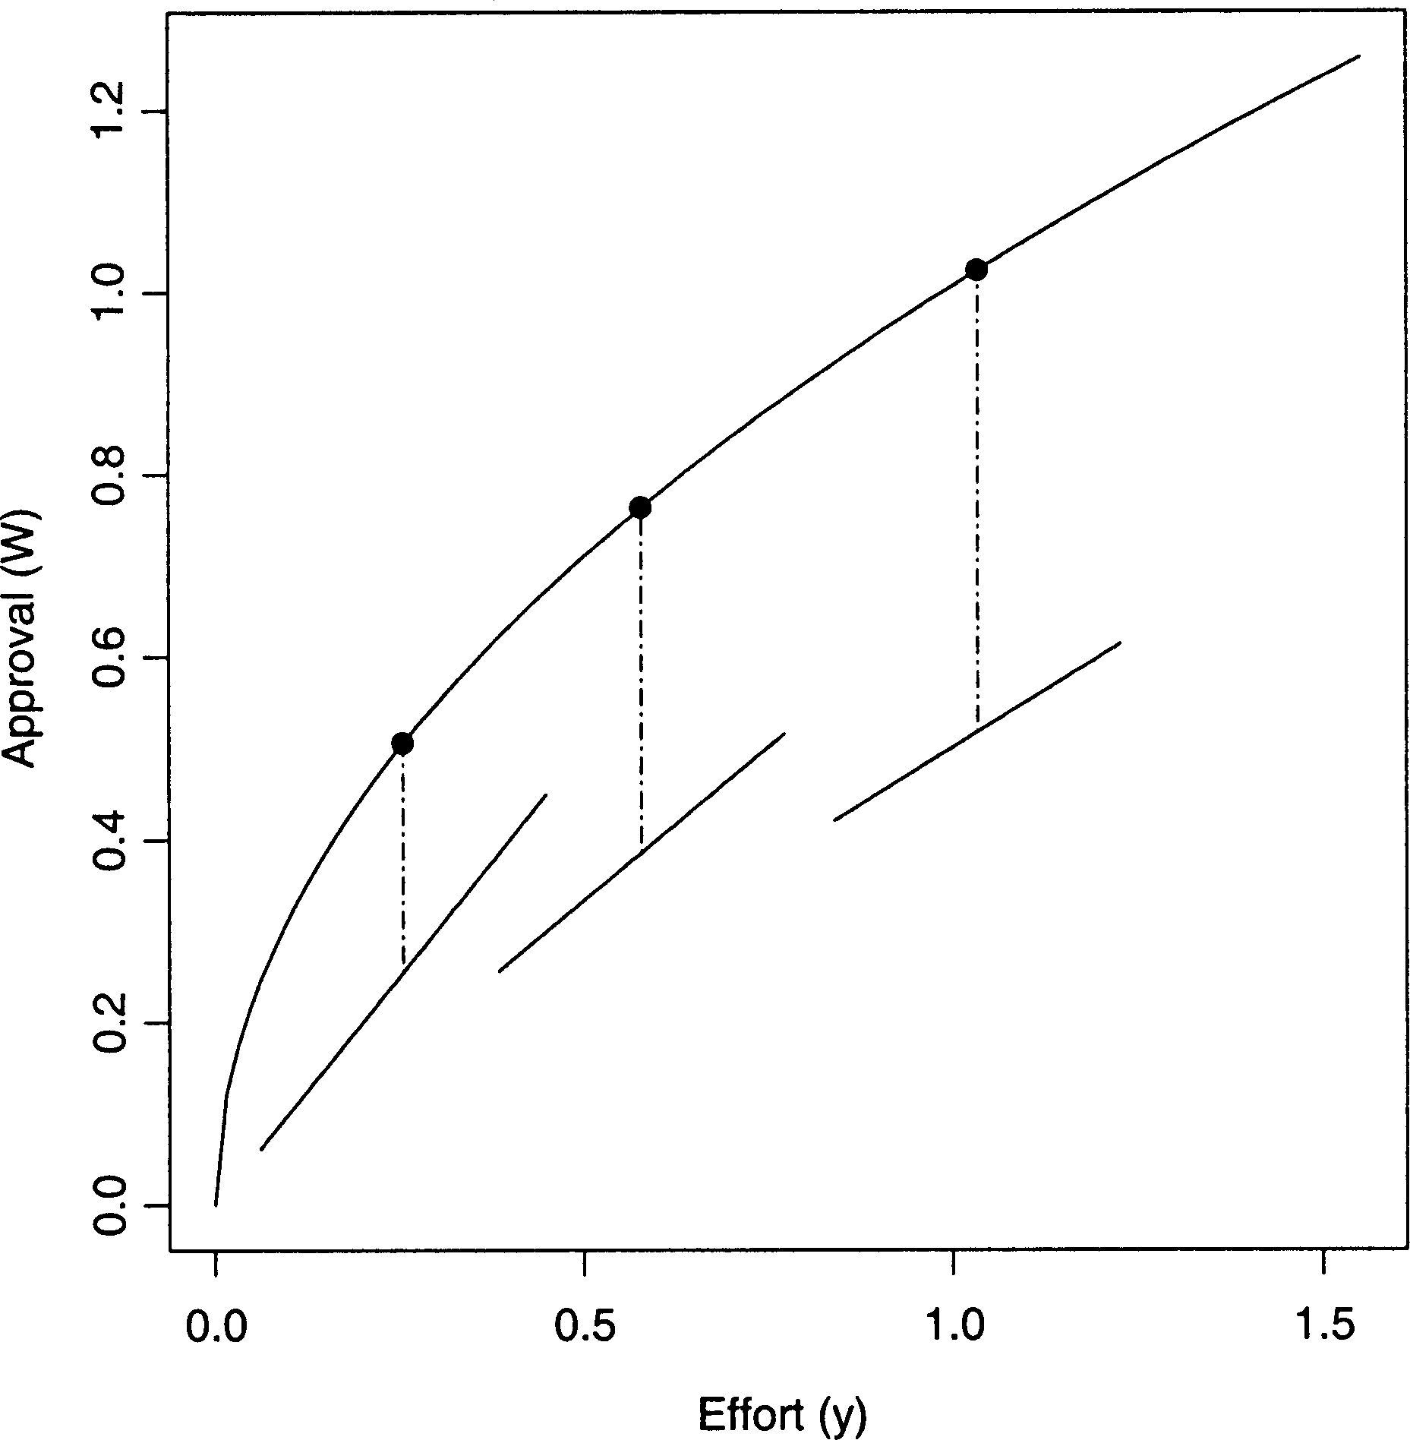

FIGURE 2 This plot adds cost schedules, *C*( *y*; *n*), for each of the three employees shown in Figure 1. The heights of the vertical segments between the cost curves and the approval schedule show that employees choose equilibrium levels of effort. All parameters equal unity in Figures 1 and 2, with the exception of *a* ¼ .5, *b* ¼ .01 and *d* ¼ -1. Since *d* ¼ -1, the lowest quality employee faces the steepest cost curve, which is evident in the left-most region of Figure 2.

We build a formal image of this process after deriving the core features of our model in the next section. We start by deriving the revenue schedule *W*( *y*), turn to equilibrium levels of effort *y*(*n*), and then specify the link between y0 and g.

## Derivations

We derive the function *W*( *y*) from Equations (1), (3) and (8).3 We start from our prior claim that employees choose an effort level *y* that maximizes the gap between rewards *W*( *y*) and costs *C*( *y*):

@*W* ¼ @*C* ¼ *cqyc*-1*nd* ð9Þ

@*y* @*y*

To get *W* on the right hand side of Equation (9), we alter Equation (3) to yield:

*U* ð*y*; *n*Þ¼ *ryanb* ¼ y0*W* ð*y*; *n*Þ ð10Þ

which we use to rewrite the quality vector *n* as:

*n* ¼ ðy0*W* ð*y*; *n*Þ=*rya*Þ1=*b* ð11Þ

This identity allows us to rewrite Equation (9) as:

@*W* ¼ *cqyc*-1hðy *W* ð*y*; *n*Þ=*rya*Þ1=*b*i*d* ð12Þ

@*y*

0

After relabeling *W*( *y*; *n*) as *W* for simplicity and collecting terms for the exponent on *y*, the differential equation in Equation (12) takes the form:

ðy0*W* =*r*Þ-*d*=*b*@*W* ¼ *cqy*ðð*bc*-*ad*Þ=*b*Þ-1@*y* ð13Þ

which we integrate:

Z ðy0*W* =*r*Þ-*d*=*b*@*W* ¼ Z *cqy*ðð*bc*-*ad*Þ=*b*Þ-1@*y* ð14Þ

After manipulating terms, adding a constant of integration *K*, and cleaning up, we have:

*W* ð*y*Þ ¼ ðð*cq*ð*b* - *d*Þ=ð*bc* - *ad*ÞÞðy0=*r*Þ*d*=*by*ð*bc*-*ad*Þ=*b* þ *K* Þ*b*=ð*b*-*d*Þ ð15Þ

or more simply:

*W* ð*y*Þ ¼ ð*Pye* þ *K* Þ*f* ð16Þ

with suitable substitutions for *P*, *e*, and *f*.

3Appendices I-III offer more detail on the derivations discussed in this section.

Using Equation (16), we now identify optimal levels of productivity as a function of the other parameters. To do so, we again set marginal rewards equal to marginal cost as:

@*W* ¼ @*C* , *f* ð*Pye* þ *K* Þ*f*-1*Peye*-1 ¼ *cqyc*-1*nd* ð17Þ

@*y* @*y*

Setting the constant of integration equal to zero affords a closed form solution as:

� l

*cqnd* 1=ð*ef* -*c*Þ

*y* ¼ *efPf*

ð18Þ

or with substitutions for *P*, *e*, and *f*:

*y* ¼ �

*nb*-*d*

l1=ð*c*-*a*Þ

ð19Þ

*cq*y0ð*b* - *d*Þ=ð*r*ð*bc* - *ad*ÞÞ

To specify Equation (19) fully, we must also clarify the functional form of y0, through which the (absence of the) boss’s autonomy g affects effort *y* and approval *W*(*y*). We see from Equation (7) that y0 is the sum of all intangible rewards raised to ð1 - gÞ=g: Therefore (as shown more fully in Appendix III), we apply W(-)from (15) to (19), substitute Wð1-gÞ=g for y0

according to (7), and sum over *n* to get P*n W* ð*y*; *n*Þ ¼ W:

2 *r* (*b*=*d* - *a*=*c*)*a*=*c* X ð*bc*-*ad*Þ=ð*c*-*a*Þ!1-*a*=*c*3g=ð1-*a*g=*c*Þ

W ¼ 4*qa*=*c*

*n*

*b*=*d* - 1 *n*

5 ð20Þ

We then solve for y0 according to Equation (7) by raising W to ð1 - gÞ=g, yielding:

2 *r* (*b*=*d* - *a*=*c*)*a*=*c* X ð*bc*-*ad*Þ=ð*c*-*a*Þ!1-*a*=*c*3ð1-gÞ=ð1-*a*g=*c*Þ

y0 ¼ 4*qa*=*c*

*n*

*b*=*d* - 1 *n*

5 ð21Þ

Consequently, the utility-per-approval experience of the boss when rewarding employees follows directly from her autonomy or bargaining power over them as a whole. When we insert Equation (21) into Equation

(19) as y0 the nature of the boss-to-employees tie affects the equilibrium levels of employees’ effort and the approval they receive.4

4Considering further the equations derived thus far yields several additional results. Start- ing with Equation (21), if g ¼ 1 then y0 ¼ 1. Under this restricted scenario, the quality levels of other employees have no effect on a given employee’s level of effort, as equation (19) makes clear. Equation (19) also shows (as one would expect) that effort is decreasing in cost *q* and increasing in demand *r*. Less intuitive are the facts that equilibria are unsustainable if *c* = *a* (returns to scale must differ across cost and utility) or for *b* ¼ *d* (differentiation in status cannot match differentiation in cost).

# MEASURING COHESION

With the preceding equations we devised a measure appropriate for clar- ifying the effects of status differentiation on the cohesion of a competitive network. We consider the network cohesive insofar as the approval accruing to each contestant changes at the same rate with time. When this is the case, contestants advance (or decline) on parallel tracks. When this is not the case, contestants move along divergent pathways. Under the second scenario, as one rival arrogates more of the boss’s approval, another may find his absolute rewards waning fast, adversely affecting the con- nectedness of the group.

We extend several lines of earlier research by conceptualizing cohesion as a function of similarity in time-changing career paths. Various scholars have noted that similarity is the primary basis for attraction: those with common traits or experiences are more likely to establish relationships with each other (e.g., Lazarsfeld and Merton, 1954). Underlying this process is individuals’ preference for similarity. Although prior investiga- tions have identified numerous dimensions on which persons may occupy nearby locations and thus establish social connections (Festinger, Schacter, and Back, 1950; Rogers and Kincaid, 1981; Marsden, 1988), we think that similarity of experience in an occupational setting is particu- larly relevant for a dynamic measure of cohesion. We do so because of the link prior research has made between homogeneity in career-related experiences and ease of social interaction (Alderfer, 1987; Ibarra, 1993), and in light of the fact that many competitive settings are marked by mutual recognition and esteem among those whose performance exceeds a socially understood ceiling (e.g., Podolny, 1993, 1994). In our model, when contestants progress similarly with time, the network they con- stitute is cohesive. Contestants then see each other as viable incumbents of the same collectivity and are thus more likely to form durable relationships.

Consider now the converse state in which contestants move along markedly different trajectories. Some are now rising in absolute rewards, others are declining. Under these circumstances, prior research suggests that cohesion will be difficult to achieve. Specifically, earlier studies support the contention that the network will be pulled apart from both the upper and lower reaches of its status hierarchy. Starting with the top of the status order, the work of several social theorists suggests that preponderant actors deliberately express (and in some cases codify and institutionalize) disdain for lower-performing actors in an effort to define and garner greater rewards for their own position (e.g., Patterson 1991:404-5; Tilly, 1998). Stated differently, higher-performing actors

consciously categorize and deride lower-performing counterparts who reside beneath a socially defined marker to amplify the value of their privileged role, thus eliminating the possibility of cohesion.

Correspondingly, at the base of the status order, feelings of relative deprivation (Merton and Rossi, 1950; Crosby, 1982) are also likely to impede the connectedness of a group. Various researchers have traced social conflict and contention to individuals’ unfavorable comparisons of their socially constructed expectations with their actual circumstances (see, e.g., Gurr, 1970; Crosby, 1976). In addition, at the organizational level, earlier research has shown that variance in rewards positively affects turnover of employees with relatively low salaries (Pfeffer and Davis-Blake, 1992) and reduces the chances of collaboration in the workplace (Pfeffer and Davis-Blake, 1993). The conceptual underpinning of these findings lies in Homans’s (1961) notion of distributive justice and in the concept of fair exchange (Eckhoff, 1974). In this work, individuals are thought to form judgments about the integrity of reward allocation systems based on social comparisons: people are constant monitors of the meting out of pecuniary rewards and praise (Markvosky, 1985). To the extent that an individual compares unfavorably with his or her peers, feelings of relative deprivation ensue. For this reason, organizational demographers and network analysts have found that sharp differences between individuals on virtually any valued characteristic invites invidious comparisons, reduces interpersonal attraction, hinders value consensus, renders communication more difficult, and thereby impedes social cohe- sion (Burt, 1982; Pfeffer, 1997).

Consequently, in our model, as social actors garner the esteem of their evaluator along parallel pathways, we assume that they (by virtue of their similar fates) will remain strongly and fully connected. We consider this approach useful given that, although most competitive systems evolve away from an equal distribution of rewards, they also vary greatly in the extent to which their occupants either rise jointly in absolute terms or instead ramify in different directions, with some declining and others ascending. We measure cohesion as the ratio of the lowest quality employee’s rate of change in approval to that of the highest quality employee’s rate of change:

r ¼ @*W* =@*b*j*n*¼minð*n*Þ @*W* =@*b*j*n*¼maxð*n*Þ

ð22Þ

Calculations (shown in Appendix IV) show that the partial derivative of approval with respect to status differentiation assumes the form:

@*W* ¼*W*  *ad*g þ  *c*  lnð*n*Þþ { g - 1 )

@*b*

ð*d* - *b*Þð*c* - *a*gÞfð*b*Þ

*c* - *a*

1 - *a*g=*c*

x "X ðln *n*Þ*n*fð*b*Þ. X *n*fð*b*Þ### ð23Þ

*n n*

where fð*b*Þ=ð*bc* - *ad*Þ=ð*c* - *a*Þ

Our measure of cohesion r has many desirable properties. One is that it equals unity when all contestants, regardless of their fixed endowment of quality *n*, advance or decline on parallel pathways. And as r departs from unity, cohesion declines. Another advantage of the measure is the infor- mation it conveys when its value is negative. When r falls below zero, the high- and low-end contestants are moving along decidedly different vec- tors; one is rising in absolute approval, the other is falling. Under r < 0, we assume that none of the benefits of cohesion are realizable, and we therefore focus on the various time points after which r assumes negative values in the next section.

## Results

Our results show when the social organization of exchange rules out the possibility of cohesion (and its concomitant advantages), and when con- testants stay connected despite mounting distinctions among them. We portray the effects of status differentiation on cohesion in two different domains: We consider first a site in which the boss enjoys autonomy in relation to her employees (g < 1), after which we move to a context in which her autonomy is weak (g > 1). We model the fates of a triad of employees, whose levels of quality we fix at 1, 1.5, and 2. We set g first to .8,

.7, and .6 to depict results for an autonomous boss, and then to 1.2 for a boss who lacks autonomy. We fix *a* in Equation (2) at .5 for decreasing returns to scale.5 We let *b* vary from .01, signifying negligible initial var- iation among employees in perceived quality, up to 3. Consistent with Spence (1974), we set *d* equal to -1, so that the most able employee incurs the lowest cost for a chosen level of effort. All other parameters—*c, r*, and *q*—stay equal to one.6

We depict the effects of status differentiation on cohesion r in Figure 3 for three values of g, each representing high autonomy enjoyed by the boss (and g ¼ .6 marking the highest state of autonomy). In each case, r clearly

5Calculation reported elsewhere (see White 1981) show that a necessary condition for positive profits is a=c < *1*=y.

6Although *r* and *q* affect important outcomes, such as levels of effort and rewards, they cancel in equation (22) and consequently have no effect on cohesion.

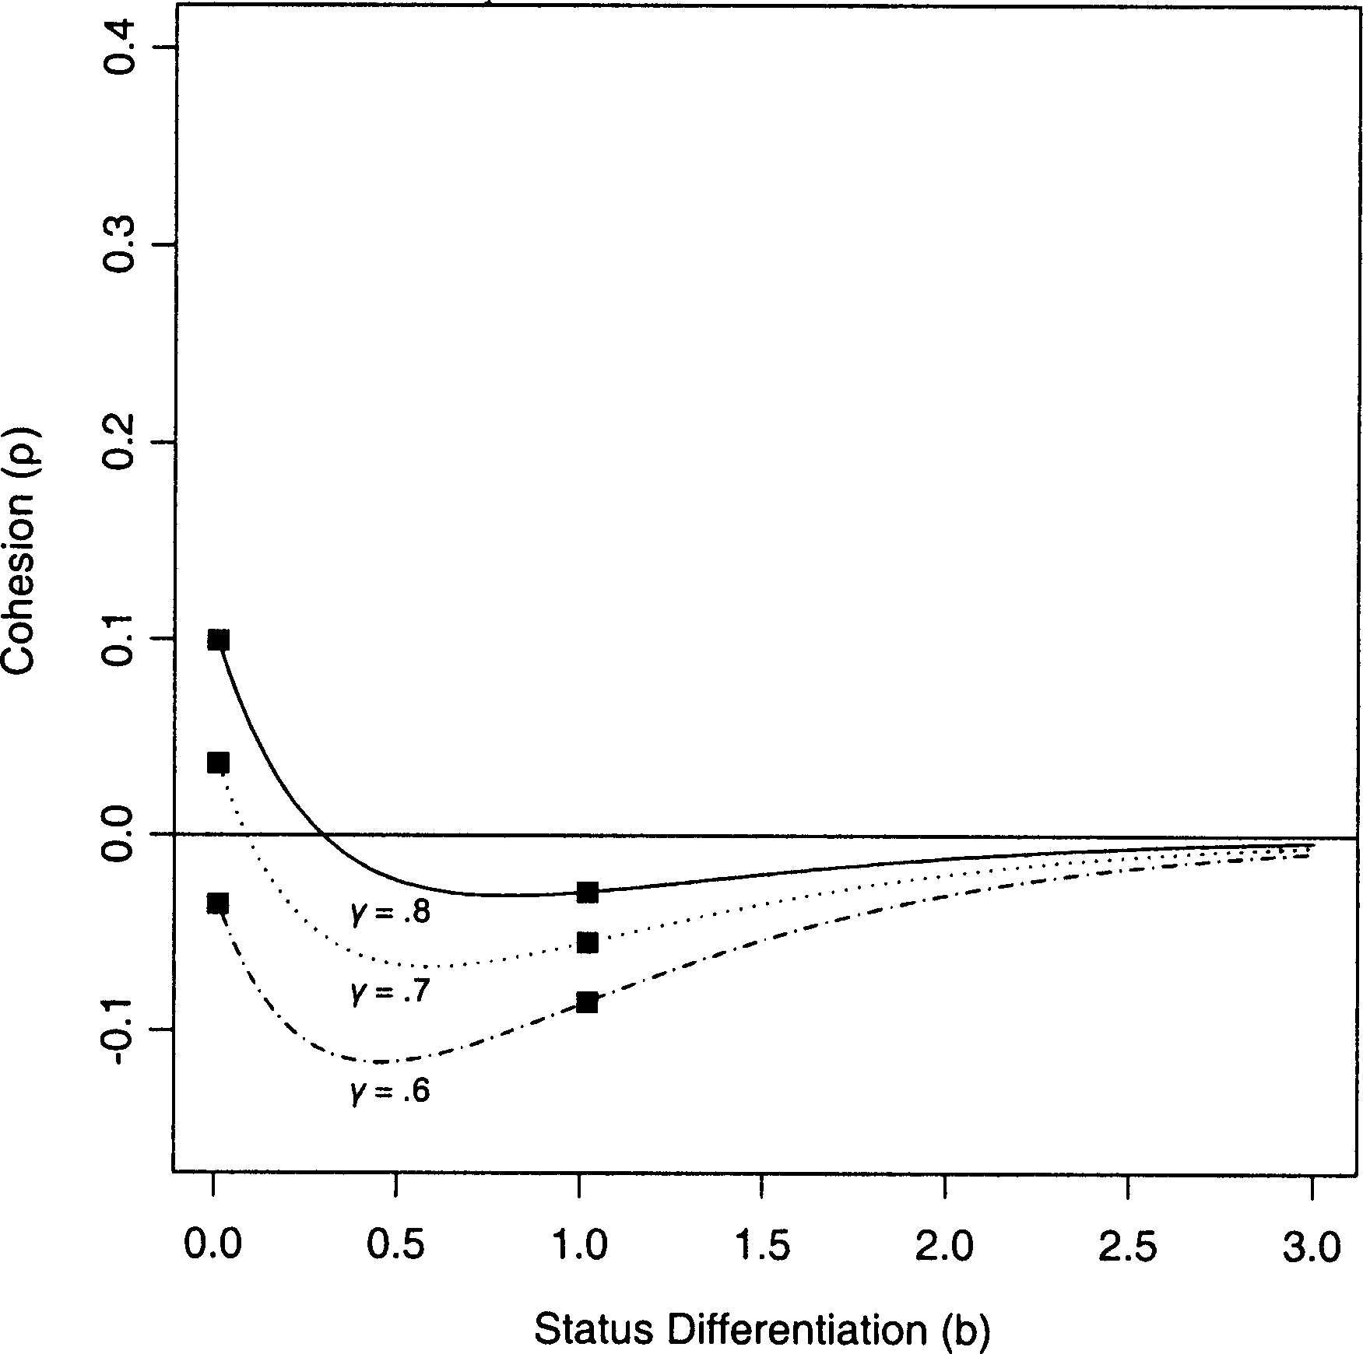

FIGURE 3 The effects of status differentiation on cohesion when the boss’s au- tonomy is high, which we denote by gamma < 1. We depict the effects of status differentiation for three levels of gamma, where the autonomy of the boss is greatest when gamma is lowest. We allow *b* to vary from .01 to 3, so that a continuous range of possible outcomes appear. We also mark specific levels of *b*—.01 and 1.02— where

1.02 is the second level of *b* derived from equation (2), if we start the competition at

*b* ¼ .01. All remaining figures are similarly marked at these two time points.

trends downward as distinctions in status grow. Substantively, this result means that contestants sort into different trajectories, and thus are less likely to realize the advantages of cohesion, as they progressively differ in status. Our results also show that the point after which cohesion assumes negative values occurs earlier, the higher the boss’s autonomy (or the lower the level of g). To depict this pattern differently, we also plot the absolute approval *W* of the low quality contestant across *b* in Figure 4. The only difference between Figures 3 and 4 is the outcome on the ordinate. The functions in Figure 4 reinforce the fact that cohesion breaks down earlier, the higher the value of gamma. Specifically, the critical value of *b* at which @*W*=@*b*j*n*¼1 intersects zero is .297105 for g ¼.8, and equals .08816 for g ¼.7,

corresponding to the values at which r equals zero in Figure 3. Together,

Figure 3 and 4 also show that @*W*=@*b*j*n*¼1 < 0 for all *b* for g ¼.6, meaning that cohesion’s benefits never surface under a highly autonomous boss.

Showing the other side of this trend, Figure 5 depicts the time-varying approval enjoyed by the high-status actor when g ¼ .6. Unlike the low- status employee—whose approval approaches zero with time—the

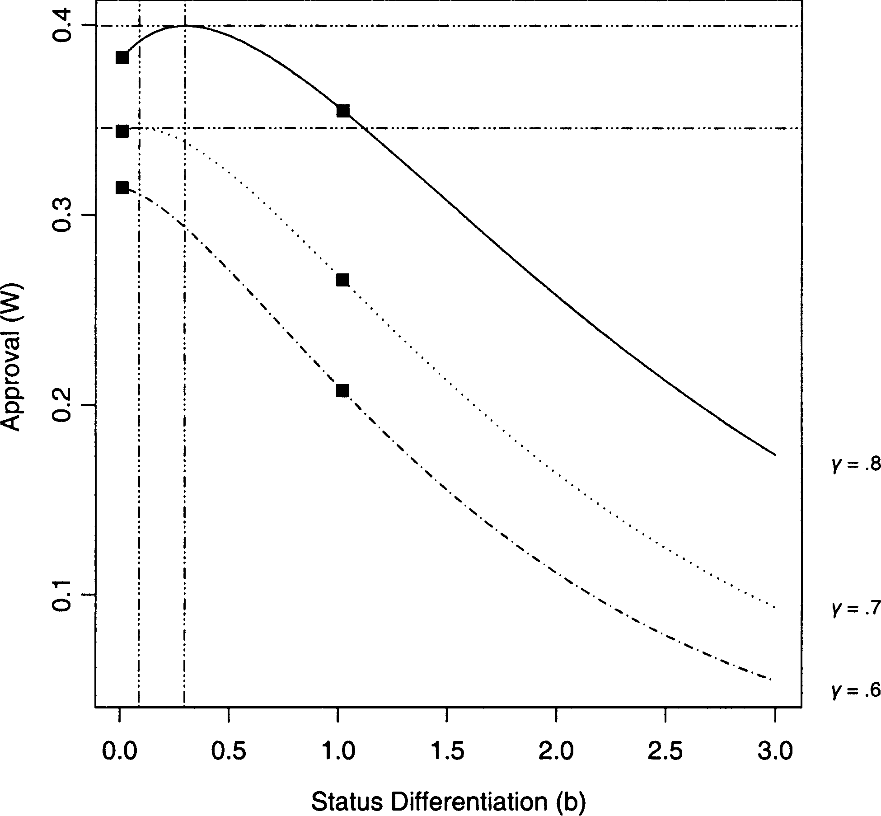

FIGURE 4 The effect of status differentiation *b* on approval *W* for the lowest- status employee (whose entry in the quality vector *n* equals 1), for three levels of gamma: .8, .7, and .6. Vertical and horizontal lines intersect at the global maxima of the approval functions in which gamma equals .8 and .7.

high-status contestant’s approval rises explosively, mirroring a salient fea- ture of many real-world tournaments. Under our model’s assumptions, an almost imperceptible initial lead in quality yields a relative gain in utility added (and thus in rewards), which then fosters a further advantage on the status axis, creating more relative gains in utility added (and in corre- sponding rewards), and so the cycle coninues.

Various scholars have of course identified such cycles in the past. Sub- stantial work has followed Gibrat’s (1931) law, for instance, effectively tracing log-normal size distributions to early differences in luck. When absolute growth (of firms’ sales or individuals’ rewards) is a function of size, small (randomly induced) advantages at the start of a contest cumulate into large inequalities over time (see Sutton, 1997; Carroll and Hannan, 2000, pp. 3157319). Similarly, writing on status hierarchies and the resulting allocation of resources among scientists, Merton (1968) stressed the relative ease with which eminent researchers multiply their stature: When more than one scientist independently makes the same discovery, credit disproportionately goes to the highest-status scientist, making it easier for him or her to make further scientific advances (and receive yet more credit), and so the feedback loop turns.

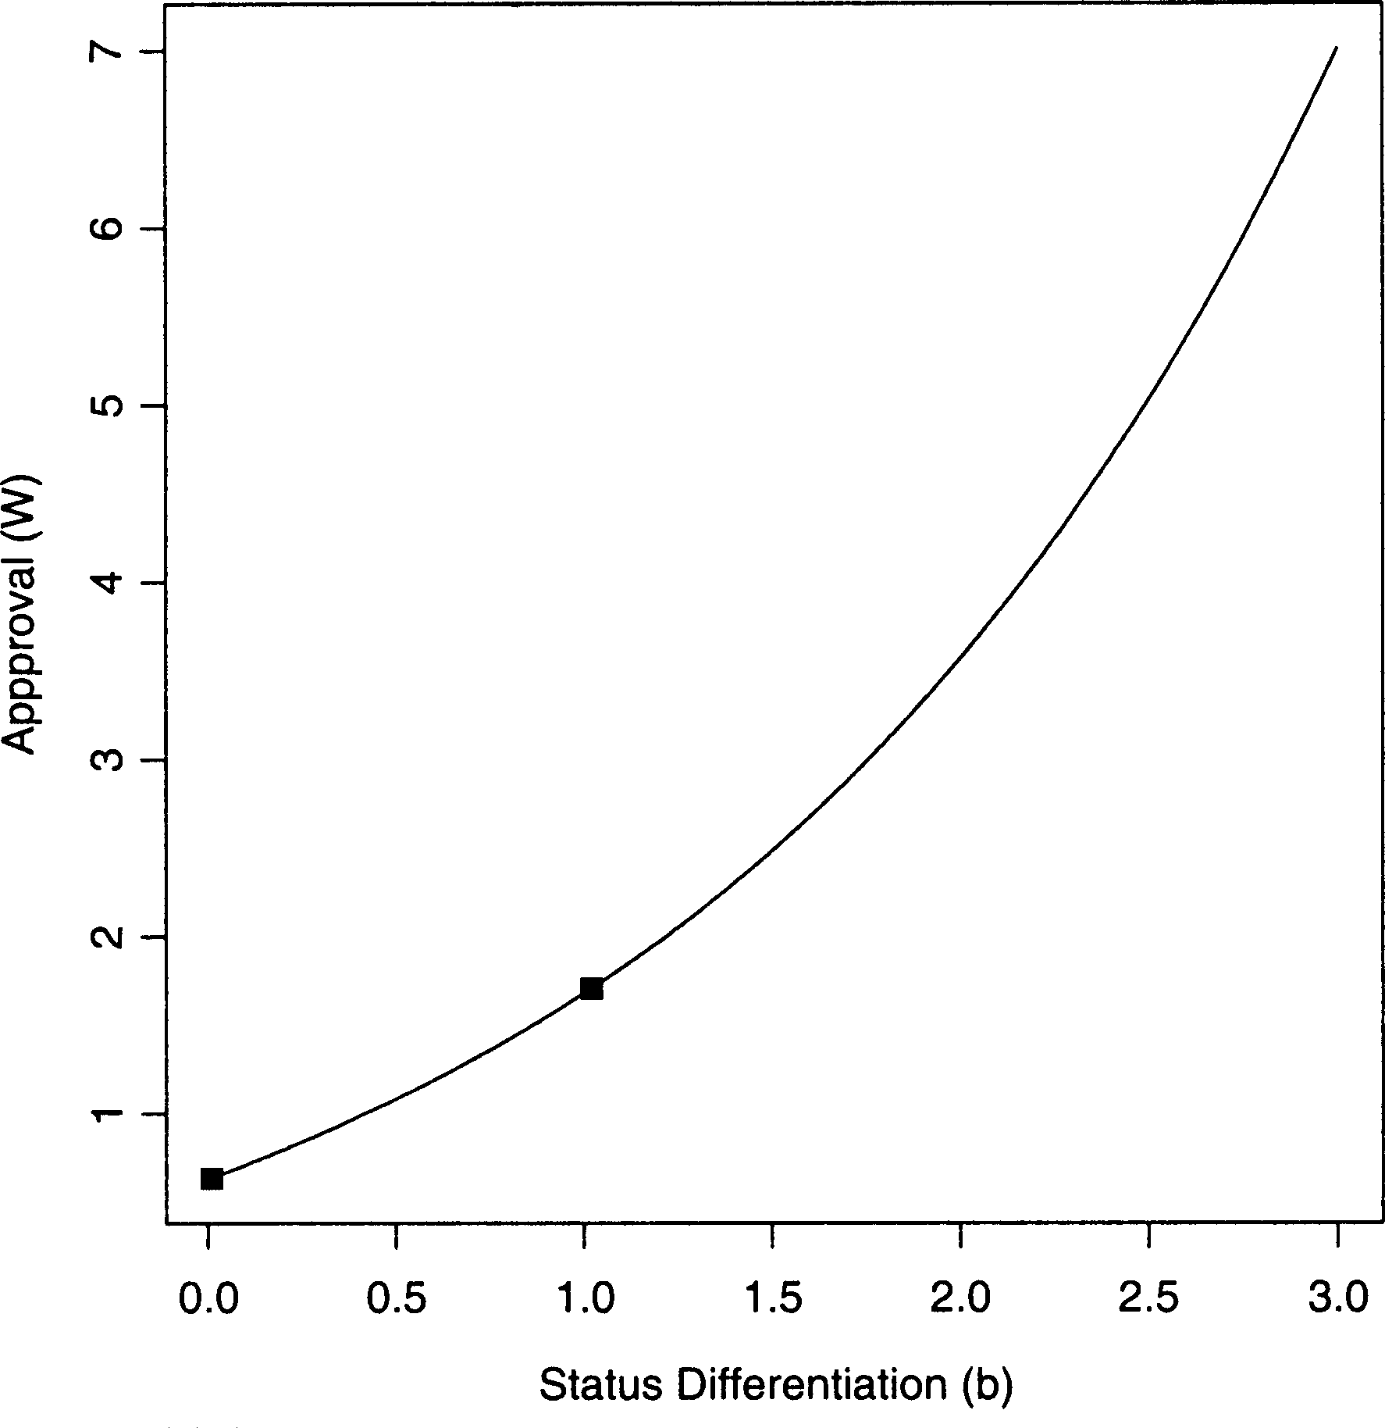

FIGURE 5 The behavior of the approval of the high-status employee (for whom *n* in equations (1) and (8) equals 2) over the differentiation process transpiring among employees when gamma equals .6.

With the exception of Merton’s scientists competing in isolation, earlier research has given insufficient attention to the effects of such cycles on the cohesion of the social structures in which they arise. While building on the insight that status is self-reinforcing, we extend past work by examining the effects of status differentiation on a triad’s social integration, thus shifting the focus from the actor to the system. And unlike the greater part of prior demographic research, which has pictured cohesion as a function of group members’ time-invariant traits, we view cohesion as the product of similarities in time-changing career paths, each of which emerges out of their collective relation with an outside evaluator.

When our measure of cohesion, shown in Equations (22) and (23), appears alongside a measure of relative approval, the primacy of the eva- luator’s autonomy as a causal factor becomes clear. Using Equations (15) and (19), it follows that:

*Wn*=*W*max - *Rn* ¼ ð*nn*=*n*maxÞð*bc*-*ad*Þ=ð*c*-*a*Þ ð24Þ

Unlike our measure of cohesion, relative approval is entirely independent of the level of the boss’s autonomy. Substituting into Equation (24) the parameter values specified previously, we find that the low-status

employee’s relative approval (for whom *n* ¼ 1) always moves as follows across status differentiation *b*:

*R*1 ¼ *e*- lnð2Þð2*b*þ1Þ ð25Þ

Stated differently, the core feature of Equations (24) and (25) is that gamma is missing. Unlike relative approval, which moves in exactly the same (negative) way for the lowest quality contestant regardless of gamma, his rate of change in *W* with *b*, which affects the cohesion of the group, does vary with the boss’s bargaining power.

Moving to the time-varying behavior of cohesion under a low autonomy boss, we see in Figure 6 that r never crosses the zero line. Additional analyses also indicate that r remains positive even at much higher levels of

*b*. This result suggests that the perfomance-related benefits of cohesion are always (in principle) achievable under a weakly autonomous boss. Com- paring the functions of Figures 3 and 6 to each other also shows that cohesion falls less precipitously when the evaluator’s autonomy is lower or gamma is higher. This difference implies that the rate of change in the system also varies with a competitive clique’s tie to an external evaluator. Specifically, our results point to the empirical possibility that the conduct- related correlates of strong ties, such as frequent contact, reciprocity, and

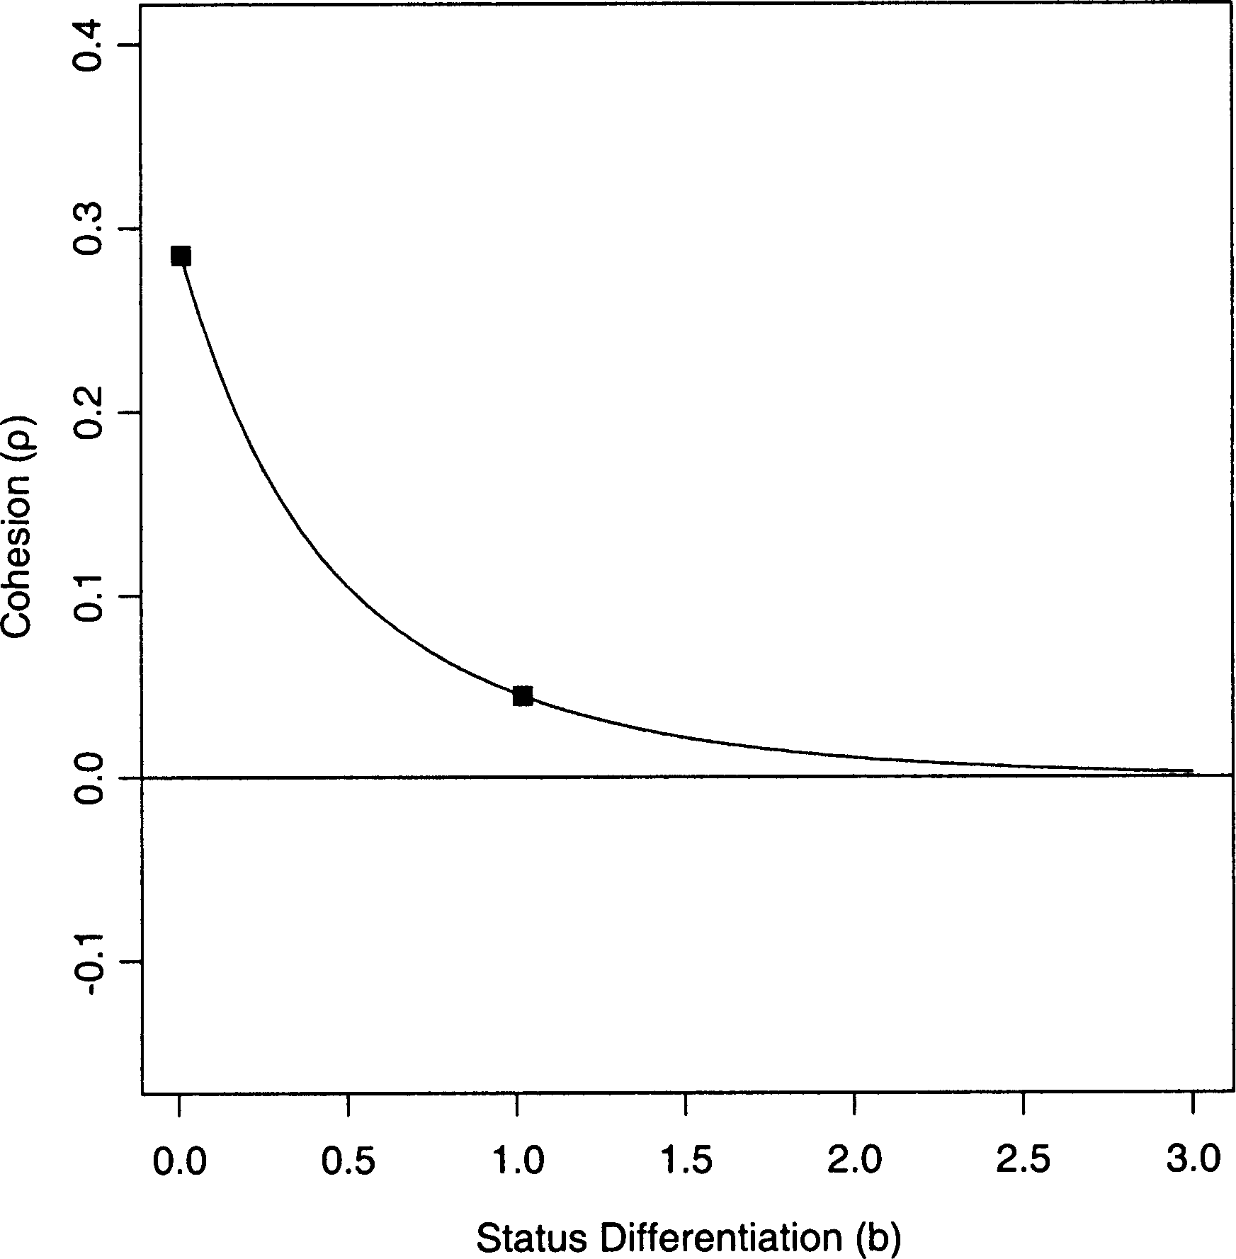

FIGURE 6 The relationship between cohesion and status differentiation when gamma equals 1.2. Unlike the trajectories of cohesion depicted in Figure 3, cohesion assumes only positive values under this value of gamma.

mutual confiding, change less rapidly when contestants’ vertical power is higher (Granovetter, 1985).

## Extensions: Other Parameter Values

At this juncture, before turning to our findings’ broader implications, it may be useful to explore the extent to which other parameters affect our main results. As we have established, the movement of r across *b* is invariant to attractiveness *r* and cost *q*. Therefore, we focus on the impact of varying *a* and *c* from Equations (1) and (8), respectively, as well as the quality of the middle-level actor, whose entry in *n* we fixed at 1.5. And since the value of the middle-quality actor only affects others’ effort *y* when gamma departs from unity, as shown in Equations (19) and (21), we consider the con- sequences of alternative starting values for gamma equal to .8 and 1.2. We also underscore the importance of keeping the parameter *d* below zero.

The general result of these further analyses is that altering the values of other parameters leaves the original set of effects largely unchanged. A specific result is that cohesion is higher when decreasing returns to scale are stronger (either by lowering *a* or raising *c*), regardless of the level of gamma. Conversely, another result is that the effect on cohesion of chan- ging the middle-level actor’s quality does depend on gamma.

To depict these outcomes, we start by replicating the plot of r as a

function of status differentiation at gamma ¼ .8, shown first in Figure 3. We do this in Figure 7, using a solid line to denote r as a function of *b* with the original parameter values. We include this function to establish a baseline suitable for comparing effects under different parameter values. Specifi- cally, additional functions show that cohesion is higher when *a* is smaller, *c* is larger, and as the quality of the middle actor equals that of the contestant whose quality had been lowest.

Similarly, we also consider the effects of varying these three parameters when the boss’s autonomy is low. We do this in Figure 8, where gamma equals 1.2, just as it did in Figure 6. Again, the solid-line function depicts cohesion as a function of status differentiation using our original set of parameters. Aside from the new effect of the middle-actor’s quality, we see the same effects as in Figure 7. On the one hand, in Figure 8, r again is higher when decreasing returns to scale (either by reducing *a* or increa- sing *c*) are sharper. On the other, whereas r discernibly increased in Figure 7 as the quality of the middle actor dropped from 1.5 to 1, here r falls with the same shift (although almost indiscernibly).

Also, to establish that an inverse relationship between quality and cost is a necessary condition for status differentiation, consider the outermost exponent in Equation (15). Clearly, if *d* were small and positive, *b* would quickly reach a stage at which approval as a function of effort is undefined.

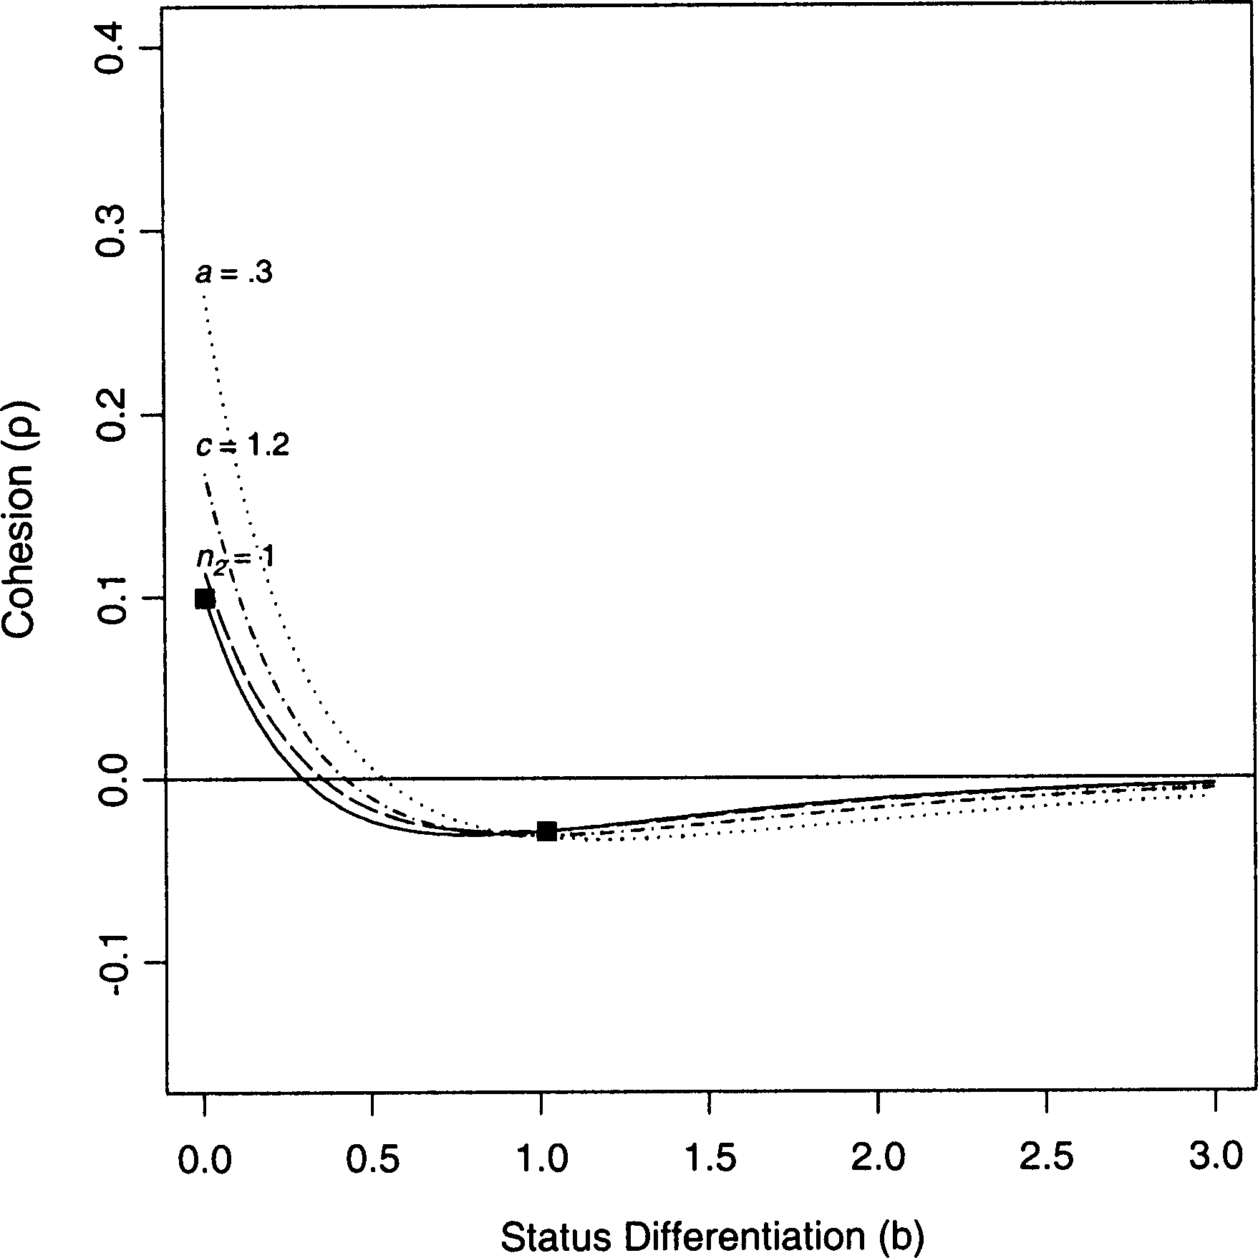

FIGURE 7 The consequences of shifting other parameters previously held fixed, when gamma equals .8. The solid7line function depicts the behavior of cohesion across status differentiation, as shown in Figure 3, under the choices of parameter values described in the text. For each of the other functions, we have only varied a single parameter, and denote its new value in the plot.

Consequently, to let *b* increase as a function of lagged differentiation, *d* < 0 must hold.

# DISCUSSION

The aim of this article has been to clarify when cohesion can coexist with status differentiation and when rising status-based differences make the cohesiveness of a social structure unachievable. Using a formal model, we have shown that, although cohesion always falls as distinctions grow, whether or not cohesion survives turns on the autonomy of an outside evaluator. We found that cohesion persists when autonomy is low and ends when it is high. Our results also established that this autonomy contracts the time frame during which cohesion survives. Our main contribution has been to show that new insights about the dynamics and structure of a social network can arise when researchers are explicit about the effects of external conditions on processes unfolding within a network. To do otherwise—to focus only on internal differences in actors’ traits—is to bypass the ways in which higher-level relations affect the processes that

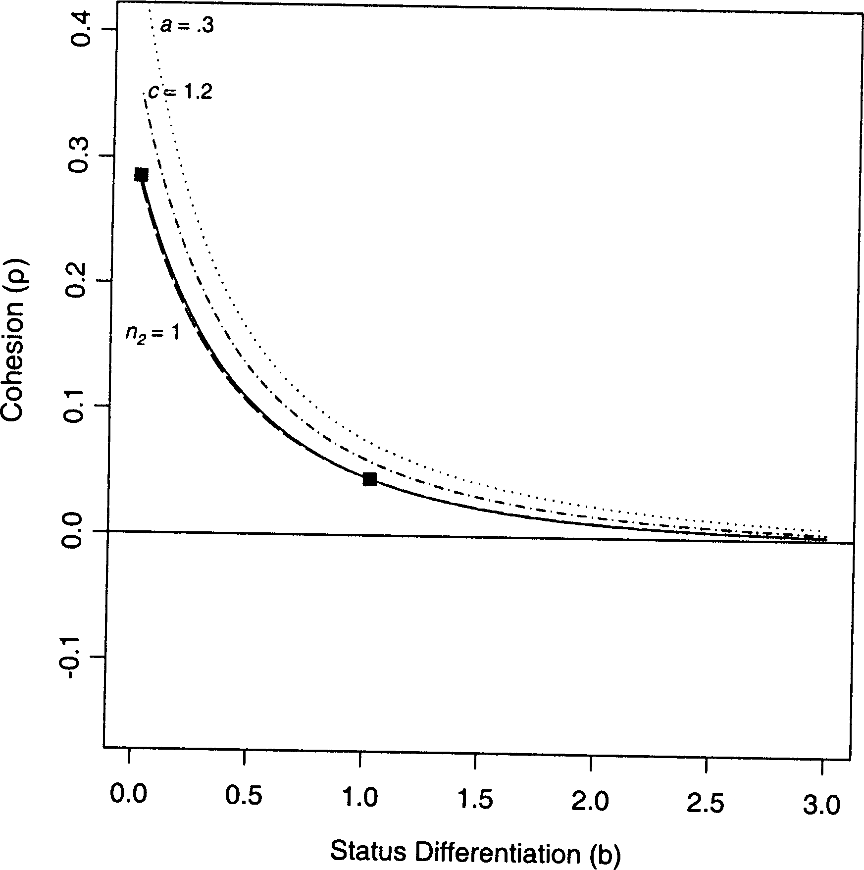

FIGURE 8 The consequences of shifting other parameters previously held fixed, when gamma equals 1.2. The solid-line function depicts the behavior of cohesion across status differentiation, as shown in Figure 6, under the choices of parameter values described in the text. As in Figure 7, for each of the other functions, we have only varied a single parameter, and denote its new value in the plot.

earlier studies have often implicitly (and incompletely) depicted as self- contained.

Needless to say, our use of an analytical model with restrictive assumptions limits the generality of these findings. Therefore, before turning to more specific implications for future empirical research, we specify several scope conditions that clarify the kinds of observable social structures for which our results are most relevant.

## Scope Conditions

Starting with the boss, we wish to underscore the importance of the pre- dictability of her evaluations. Within our model, employees select equili- brium levels of effort based on their inference of the approval schedule, which is a function of effort and status differentiation. Clearly, not all competitive contexts are overseen by an evaluator whose style of leader- ship and logic of reward allocation are inferable. To the contrary, many evaluators deliberately foster uncertainty among their subordinates to elicit greater productivity from them (Leifer and White, 1986; White, 1992:28176).

When this occurs, even if approval is dispensed by the boss, by design she makes these allocations in a seemingly stochastic fashion, thereby ruling out the continuous process of status differentiation we have depicted. Under a strategically or unintentionally erratic boss, choices about levels of effort would have to be made according to decision rules that differ from the optimizing logic on which our model turns. Therefore, an important scope condition for our model is the presence of a boss whose model of reward allocation employees can decipher and anticipate through time.

Naturally, this first scope condition entails a second, which is that employees observe each other’s effort and rewards. We expect to see the trends yielded by our model in contexts where the monitoring of others is a salient process. In modeling cohesion-related dynamics among a set of employees, we have thus understood the evolving structure they constitute as a market in White’s (1981) sociological terms: as a clique of producers watching each other. Through mutual monitoring employees infer the relationship between approval and effort and anticipate how this relation- ship shifts as status differentiation unfolds. Consequently, the public nature of approval allocation not only alters the level of cohesion in the network. Such exchanges between the boss and her subordinates also guide their choices of effort, out of which the status structure among them progres- sively emerges.

We see the persistence of competition as another requirement for observing our results. Although competition is taken for granted in many formal models, it is of course by no means ubiquitous. Altruism, for example, may surface instead as the ascendant factor behind the evolution of a social structure (see, e.g., Gintis’ 2000 model of ‘‘strong reciprocity’’). Yet when competition is absent or is eclipsed by self-sacrifice, it is easy to imagine a disruption of the sorting process depicted by our framework. Specifically, the highest status contestant might assist his lower status counterparts, instead of expending effort on tasks from which the boss directly derives utility. Without his commitment to a competitively induced, equilibrium level of effort, status differentiation, and thus the reduction of cohesion, might unfold in ways that differ entirely from our portrayal.

Conditions attached to contestants’ levels of quality also circumscribe the generality of our findings. First, as noted above, quality and cost must vary inversely (Spence, 1974); otherwise, quality cannot serve as the basis for differences in status. Second, the process of status differentiation in our model never gets started apart from differences in actual quality, although these distinctions are scarcely visible to the boss before employees begin producing. Yet without variation in the quality vector, employees would exert precisely the same levels of effort (and thus obtain identical rewards) round after round, never initiating a skewed distribution in the accrual of intangible rewards. Ultimately, therefore, the status differentiation and

changes in cohesion we illustrate have their provenance in distinctions in ability (cf. Scherer, 1970:1257130 for luck as an alternative).

While the conditions necessary for the operation of our model certainly do not characterize all social settings, they do reside in several. We contend that in a number of contexts—for instance, tryouts for sports teams, auditions for theatrical performances, first-year courses in professional schools, and summer internships at large firms—contestants start as near status-equivalents and then sort into a skewed hierarchy as soon as they start producing. Our findings bear directly on such settings when con- testants forecast evaluators’ rewards through mutual monitoring, continue to compete with each other, and vary in quality so that a chosen expen- diture of effort is easiest for the highest quality contestant. Under those conditions, our findings yield two main implications, which we state as conjectures, relevant to future research on topics related to our own.

## Conjectures

We pair each conjecture with a specific assumption about the advantages of cohesion—related to motivation, information, trust, and collaboration— mentioned previously. Of course, the larger objectives served by such advantages are by no means uniform. On the one hand, a cohesive group may be able to produce better products or services for an external actor than a sparsely connected group. This possibility mirrors the imagery of diffusion models (Coleman, Katz, and Menzel, 1966; cf. Bothner 2003), where cohesive ties make it easier for social actors to keep up with new advances and better serve their constituents. On the other hand, although earlier studies have mainly extolled the virtues of cohesion, it is equally plausible that a cohesive workgroup poses more problems for a boss than one whose level of cohesion is low. This possibility reflects resource mobilization models (see McAdam, 1982:20735 for a review), where cohesive ties lower the costs of reconfiguring relations with authorities. Using these divergent scenarios, we conclude with two corresponding conjectures about the likely actions of a boss, or external evaluator more generally, faced with status-driven changes in cohesiveness among his or her subordinates.

Our first conjecture has to do with an external evaluator’s propensity to engineer a culture (Kunda, 1992) congenial to the integration of contestants. Under the assumption that cohesion in the early stages of a contest brings forth advantages *for evaluators*, we expect that *autonomous evaluators establish beliefs and values that counter the disintegrative force of status differentiation*. Statements by the boss about the sacrosanct quality of the group as a whole, or the intrinsic ‘‘worth’’ of each member, are examples of these cultural factors. We therefore see culture as a means of social control,

or more precisely as a ‘‘tool-kit’’ (Swidler, 1986) assembled and used by the boss to attach contestants to each other. Similar to the first meeting of a cross-functional product team, when representatives of various functions freely share data before invidious comparisons set in, we found that r was high at first, but eventually fell below zero. And the lower the value of gamma (the higher the boss’ autonomy), the earlier this phase transition occurred. Substantively, this pattern suggests the cultural interventions favorable to cohesion occur sooner, the higher the evaluator’s autonomy.7

Our second conjecture pertains to the feedback likely to exist empiri- cally between cohesion and autonomy. Under the assumption that cohesion in the early stages of a contest yields advantages *for contestants*, we expect that *weakly autonomous evaluators establish beliefs and values that advance the disintegrative force of status differentiation*. Work at the intersection of social networks and collective action offers examples of these cohesion-induced advantages. Tilly (1978), for instance, argued that cohesion, together with the clarity of a group’s identity, critically affects its ability to mobilize and realize its interests (through striking, lobbying, protesting, and so forth). With stronger bonds among insurgents, the odds of improving their standing relative to a dominant group rise. Similarly, an implication of Burt’s (1999) work is that the cohesion not only raises a group’s ability to pursue its interests despite others’ opposition. Since cohesion fuels distrust toward outsiders, it may also make a group’s members more prone to mobilize. Where these studies converge is on the claim that cohesion magnifies the ‘‘groupness’’ of a group (Fararo and Doreian, 1998) and it resulting chances of mobilizing successfully at the expense of an outside party.

When coupled with these lines of research, our findings bring into focus

the possibility that production for a weakly autonomous boss induces feedback and a divisive cultural response on his or her part. Where earlier work stressed the effect of greater cohesion on a chosen group’s power over outsiders, our results point to the reverse process in which a group’s greater power with respect to outsiders (higher gamma) renders them more cohesive. Although we have fixed gamma when identifying our

7Although this conjecture deliberately goes beyond the model itself, pertaining to ‘‘back- stage’’ activities in Goffman’s (1959) terms, it is easy to imagine how to express it in the mod- el’s language. Specifically, if we assume (as we have) that cultural intervention by the boss increases cohesion, it could do so by raising the minimum value of the quality vector *n*. This would mean that the lowest quality actor (by virtue of a cultural intervention directed at him in particular) increased his level of fit with the boss. Were we to model the effect of culture on cohesion, it would then be necessary to decide between these approaches: (*a*) using the measure of cohesion presented in Equation (22) while relaxing our assumptions about the invariant nature of quality or (*b*) extending our measure of cohesion so that it becomes a combination of structural and cultural elements.

results, it is not difficult to conceive of a cycle in which higher gamma (lower autonomy on the part of the boss) promotes cohesion, which then raises gamma further, in turn making cohesion easier to sustain, elevating gamma again, and so on. When this process of escalation occurs empirically (or appears likely to do so), we conjecture that a weakly autonomous boss will then intervene on the cultural plane to divide his or her subordinates. Such interventions have of course attracted scholarly attention in many fields, starting in sociology with Simmel’s (1902) discussion of ‘‘divide and rule’’ strategies (cf. Burt, 1992). Unlike the typically public attempts of an autonomous boss to enhance cohesion, we envision a weakly autonomous boss engaging in private efforts to force apart his or her subordinates, thus covertly widening gaps already induced by the process of status differentiation.

## APPENDIX I: DERIVATION OF *W*(*y*):

Starting with the claim that employees choose effort at which marginal approval equals marginal cost, shown in Equation (9) of the text (assuming throughout y ¼ y0):

@*W* ¼ @*C* ¼ *cqyc*-1*nd*

@*y* @*y*

And from Equation (3):

so that:

*U* ð*y*; *n*Þ¼ *ryanb* ¼ y*W* ð*y*; *n*Þ

*n* ¼ ððy*W* ð*y*; *n*ÞÞ=*rya*Þ1=*b*

Consequently, *n* may be substituted into (9) to yield:

@*W* ¼ @*C* ¼ *cqyc*-1½ððy*W* ð*y*; *n*ÞÞ=*rya*Þ1=*b*]*d*

@*y* @*y*

Simplifying the right-hand side (and re-labeling *W*(*y; n*) as *W* ) before collecting terms for the exponent on *y*:

@*W* ¼ @*C* ¼ *cqyc*-1ðy*W* Þ*d*=*b*=ð*rya*Þ*d*=*b*

@*y* @*y*

@*W* ¼ @*C* ¼ *cqyc*-1ðy*W* Þ*d*=*b*=ð*rd*=*byad*=*b*Þ

@*y* @*y*

Collecting terms for the exponent on *y*:

*yc*-1=*yad*=*b* = *yc*-1-*ad*=*b* = *ybc*=*b*-*b*=*b*-*ad*=*b* = *y*ðð*bc*-*ad*Þ=*b*Þ-1

and reinserting *y* back into the differential equation:

@*W* ¼ @*C* ¼ *cqy*ðð*bc*-*ad*Þ=*b*Þ-1ðy*W* =*r*Þ*d*=*b*

@*y* @*y*

Rearrange terms before integrating:

ðy*W* =*r*Þ-*d*=*b*@*W* ¼ *cqy*ðð*bc*-*ad*Þ=*b*Þ-1@*y*

Now integrate:

Z ðy*W* =*r*Þ-*d*=*b*@*W* ¼ Z *cqy*ðð*bc*-*ad*Þ=*b*Þ-1@*y*

Manipulating terms, adding a constant of integration, and cleaning up:

Z *W* -*d*=*b*@*W* ¼ Z ðy=*r*Þ*d*=*bcqy*ðð*bc*-*ad*Þ=*b*Þ-1@*y*

*W* -*d*=*b*þ1=ð-*d*=*b* þ 1Þ¼ ðy=*r*Þ*d*=*bcqy*ð*bc*-*ad*Þ=*b*=ðð*bc* - *ad*Þ=*b*Þþ *K* ð*b*=ð*b* - *d*ÞÞ*W* ð*b*-*d*Þ=*b* ¼ ð*b*=ð*bc* - *ad*ÞÞðy=*r*Þ*d*=*bcqy*ð*bc*-*ad*Þ=*b* þ *K W* ð*b*-*d*Þ=*b* ¼ ð*cq*ð*b* - *d*Þ=ð*bc* - *ad*ÞÞðy=*r*Þ*d*=*by*ð*bc*-*ad*Þ=*b* þ *K*

*W* ð*y*Þ ¼ ðð*cq*ð*b* - *d*Þ=ð*bc* - *ad*ÞÞðy=*r*Þ*d*=*by*ð*bc*-*ad*Þ=*b* þ *K* Þ*b*=ð*b*-*d*Þ

Or simply: *W* ð*y*Þ ¼ ð*Pye* þ *K* Þ*f* with substitutions for *P, e*, and *f*.

## APPENDIX II: DERIVATION OF *y*(*n*):

Starting with optimal levels of effort and using the simplified version of

*W(y)* in (16):

@*W* ¼ @*C* () *f* - ð*Pye*Þ*f*-1 - *Peye*-1 ¼ *cqyc*-1*nd*

@*y* @*y*

Cleaning up the left-hand side:

*f* - *Pf* -1 - *yef* -*e* - *Peye*-1 ¼ *cqyc*-1*nd efPf yef* -1 ¼ *cqyc*-1*nd*

*yef* -*c*

*cqnd*

¼ *efPf*

*cqnd* 1=ð*ef* -*c*Þ

( )

*y* ¼ *efPf*

Using Equations (15) and (16) from the text:

*e* ¼ *bc* - *ad* and *f* ¼ *b*

*b b* - *d*

Therefore, the exponent 1=ð*ef* - *c*Þ takes the form:

�*bc* - *ad*

-1 *d*

l

�

- *c* ¼

ð*c* - *a*Þ

-1

¼

l

*b* - *d* ( 1 )

*b* - *d*

*b* - *d*

*d c* - *a*

Consequently, *y* may be expressed as:

Let *X* ¼ *b*-*d* to simplify:

*d*

*d*

*y* ¼ *efPf*

(*cqn* )*b*-*d* - 1

( *nb*-*d*

*y* ¼

*d c*-*a*

)1=ð*c*-*a*Þ

ð*ef* =*cq*Þ*xPb*=*d*

Substituting parameters for *e, f*, and *P* in the denominator brings us to:

2 "( )*X* � l*b*=*d*#-131=ð*c*-*a*Þ

*y* ¼ 4*n*

5

*b*-*d bc* - *ad*

*cq*ð*b* - *d*Þ

*cq*ð*b* - *d*Þ

*bc* - *ad* - ðy0=*r*Þ

*d*=*b*

Collecting ðy0=*r*Þ:

2

"( )*X* � l*b*=*d*

#-131=ð*c*-*a*Þ

*y* ¼ 4*n*

*b*-*d bc* - *ad*

*cq*ð*b* - *d*Þ

*cq*ð*b* - *d*Þ

*bc* - *ad*

ðy0=*r*Þ 5

Getting the same base, by changing *X* to -*X*:

2 "( )-*X* � l*b*=*d* #-131=ð*c*-*a*Þ

*y* ¼ 4*n*

*b*-*d cq*ð*b* - *d*Þ

*bc* - *ad*

*cq*ð*b* - *d*Þ

*bc* - *ad*

ðy0=*r*Þ 5

With *X* ¼ *b*-*d* ; the result is:

*d*

*y* ¼ �

*nb*-*d*

l1=ð*c*-*a*Þ

*cq*y0ð*b* - *d*Þ=ð*r*ð*bc* - *ad*ÞÞ

## APPENDIX III: DERIVATION *u*0 VIA *W*

Substitute *W*ð1-gÞ=g, aggregate approval raised to ð1 - gÞ=g, for y0 in *W(y)*

and *y(n)* in Equations (15) and (19), respectively.

*W* ¼ ½ð*cq*ð*b* - *d*Þ=ð*bc* - *ad*ÞÞð*W*ð1-gÞ=g=*r*Þ*d*=*by*ð*bc*-*ad*Þ=*b* þ *K* ]*b*=ð*b*-*d*Þ

with *K* ¼ 0:

*y* ¼ "

*nb*-*d*

*cqW*ð1-gÞ=gð*b* - *d*Þ=ð*r*ð*bc* - *ad*ÞÞ

#1=ð*c*-*a*Þ

*W* ¼ ð*cq*ð*b* - *d*Þ=ð*bc* - *ad*ÞÞ*b*=ð*b*-*d*Þð*W*ð1-gÞ=g=gÞ*d*=ð*b*-*d*Þ*y*ð*bc*-*ad*Þ=ð*b*-*d*Þ

Substituting *y* into *W* yields:

*cq*ð*b* - *d*Þ *b*=ð*b*-*d*Þ *W*ð1-gÞ=g *d*=ð*b*-*d*Þ

*W* ¼

*bc* - *ad*

*r*

" # *bc*-*ad*

ð*b*-*d*Þð*c*-*a*Þ

x

*nb*-*d*

*cqW*ð1-gÞ=gð*b* - *d*Þ=ð*r*ð*bc* - *ad*ÞÞ

*cq*ð*b* - *d*Þ *b*=ð*b*-*d*Þ *W*ð1-gÞ=g *d*=ð*b*-*d*Þ

*W* ¼

*bc* - *ad r*

h i *bc*-*ad bc*-*ad*

x *cqW*ð1-gÞ=gð*b* - *d*Þ=ð*r*ð*bc* - *ad*ÞÞ ð*b*-*d*Þð*a*-*c*Þ · *n c*-*a*

Cleaning up the right hand side by simplifying the exponent on *W*:

ð*W*ð1-gÞ=gÞ*d*=ð*b*-*d*Þð*W*ð1-gÞ=gÞ *bc*-*ad* ¼ hð*W*ð1-gÞ=gÞ1=ð*b*-*d*Þi*d*

ð*b*-*d*Þð*a*-*c*Þ

Simplifying terms on (1/*r*):

x hð*W*ð1-g=gÞÞ1=ð*b*-*d*Þið*bc*-*ad*Þ=ð*a*-*c*Þ

¼ ð*W*ð1-gÞ=gÞ1=ð*b*-*d*Þ *c*ð*b*-*d*Þ=ð*a*-*c*Þ

h i

¼ ð*W*ð1-gÞ=gÞ*c*=ð*a*-*c*Þ

ð1=*r*Þ*d*=ð*b*-*d*Þð1=*r*Þ *bc*-*ad* ¼ ð1=*r*Þ*ad*-*dc*þ*bc*-*ad* ¼ ð1=*r*Þ *c*ð*b*-*d*Þ ¼ *rc*=ð*c*-*a*Þ

ð*b*-*d*Þð*a*-*c*Þ

ð*b*-*d*Þð*a*-*c*Þ

ð*b*-*d*Þð*a*-*c*Þ

Simplifying *cq*(*b*-*d*)/(*bc*-*ad*) as:

*b* þ *bc*-*ad*

*a*=ð*a*-*c*Þ

½*cq*ð*b* - *d*Þ=ð*bc* - *ad*Þ]*b*-*d* ð*b*-*d*Þð*a*-*c*Þ ¼ ½*cq*ð*b* - *d*Þ=ð*bc* - *ad*Þ]

With these simplifications, the result is:

*W* ¼ ð*W*ð1-gÞ=gÞ*c*=ð*a*-*c*Þ*rc*=ð*c*-*a*Þ½*cq*ð*b* - *d*Þ=ð*bc* - *ad*Þ]*a*=ð*a*-*c*Þ*n*ð*bc*-*ad*Þ=ð*c*-*a*Þ

Now, summing both sides over *n*:

X

*W* = *W*

*n*

X

¼ ð*W*ð1-gÞ=gÞ*c*=ð*a*-*c*Þ*rc*=ð*c*-*a*Þ½*cq*ð*b* - *d*Þ=ð*bc* - *ad*Þ]*a*=ð*a*-*c*Þ *n*ð*bc*-*ad*Þ=ð*c*-*a*Þ

*n*

Collect *W* on the left-hand side:

*W* - ð*W*ð1-gÞ=gÞ*c*=ð*c*-*a*Þ ¼ *rc*=ð*c*-*a*Þ½*cq*ð*b* - *d*Þ=ð*bc* - *ad*Þ]*a*=ð*a*-*c*Þ

X

x *n*ð*bc*-*ad*Þ=ð*c*-*a*Þ

*n*

X

*W*ð*c*-*a*gÞ=gð*c*-*a*Þ ¼ g*c*=ð*c*-*a*Þ½*cq*ð*b* - *d*Þ=ð*bc* - *ad*Þ]*a*=ð*a*-*c*Þ *n*ð*bc*-*ad*Þ=ð*c*-*a*Þ

*n*

Pulling out *q*:

*W*ð*c*-*a*gÞ=gð*c*-*a*Þ ¼ g*c*=ð*c*-*a*Þ*qa*=ð*a*-*c*Þðð*cb* - *cd*Þ=ð*bc* - *ad*ÞÞ*a*=ð*a*-*c*Þ x *n*ð*bc*-*ad*Þ=ð*c*-*a*Þ

X

*n*

*W*ð*c*-*a*gÞ=gð*c*-*a*Þ ¼ g*c*=ð*c*-*a*Þð1=*q*Þ*a*=ð*c*-*a*Þðð*bc* - *ad*Þ=ð*cb* - *cd*ÞÞ*a*=ð*c*-*a*Þ x *n*ð*bc*-*ad*Þ=ð*c*-*a*Þ

X

*n*

Raising both sides to (*c*-*a*)/*c*:

1-ð*a*=*c*Þg

*W* g ¼

*r* (*bc* - *ad*)*a*=*c*( X

*n*ð*bc*-*ad*Þ=ð*c*-*a*Þ

)1-*a*=*c*

*qa*=*c*

*cb* - *cd n*

Solve for *W* as:

*W* ¼ " *r*

(*b*=*d* - *a*=*c*)*a*=*c*( X

*n*ð*bc*-*ad*Þ=ð*c*-*a*Þ

)1-*a*=*c*#g=ð1-*a*g=*c*Þ

*qa*=*c*

*b*=*d* - 1 *n*

Using the fact that y0 ¼ Wð1-gÞ=g, the result is:

*r*

"

y0 ¼

(*b*=*d* - *a*=*c*)*a*=*c*( X

*n*ð*bc*-*ad*Þ=ð*c*-*a*Þ

)1-*a*=*c*#ð1-gÞ=ð1-*a*g=*c*Þ

*qa*=*c*

*b*=*d* - 1 *n*

## APPENDIX IV: DERIVATION OF **@***W*/ **@***b*

Starting from Equation (20) in the text:

W ¼ " *r* (*b*=*d* - *a*=*c*)ð*a*=*c*Þ( X *n*ð*bc*-*ad*Þ=ð*c*-*a*Þ)1-*a*=*c*#g=ð1-*a*g=*c*Þ

*qa*=*c*

*b*=*d* - 1 *n*

which may be reexpressed as:

)

### W ¼ (

*r* )g=ð1-*a*g=*c*Þ(*b*=*d* - *a*=*c*)ð*a*=*c*Þg=ð1-*a*g=*c*Þ( X

*n*ð*bc*-*ad*Þ=ð*c*-*a*Þ

gð1-*a*=*c*Þ

1-*a*g=*c*

*qa*=*c*

*b*=*d* - 1 *n*

Using the fact that individual approval equals the product of total approval and market share:

*n*ð*bc*-*ad*Þ=ð*c*-*a*Þ *W* ¼ W - P *n*ð*bc*-*ad*Þ=ð*c*-*a*Þ

*n*

and letting *m* = ( *r* Jg=ð1-*a*g=*c*Þ to simplify, we have:

*qa*=*c*

( )

)

*W* ¼ *m*

*b*=*d* - *a*=*c a*g=ð*c*-*a*gÞ

*b*=*d* - 1

*n*ð*bc*-*ad*Þ=ð*c*-*a*Þ

( X*n*

*n*ð*bc*-*ad*Þ=ð*c*-*a*Þ

g-1 1-*a*g=*c*

or alternatively:

where

*f* ð*b*Þ ¼

*W* ¼ *mf* ð*b*Þ*g*ð*b*Þ*h*ð*b*Þ

*b d a c a*g=ð*c*-*a*gÞ

( = - = )

; *g*ð*b*Þ ¼ *n*ð*bc*-*ad*Þ=ð*c*-*a*Þ; and

*b*=*d* - 1

! g-1

Therefore:

*h*ð*b*Þ ¼

*n*ð*bc*-*ad*Þ=ð*c*-*a*Þ

*n*

X

1-*a*g=*c*

@*W* ¼ *m*ð*f* 0ð*b*Þ*g*ð*b*Þ*h*ð*b*Þþ *f* ð*b*Þ*g*0ð*b*Þ*h*ð*b*Þþ *f* ð*b*Þ*g*ð*b*Þ*h*0ð*b*ÞÞ

@*b*

*W*

¼ *f* ð*b*Þ*g*ð*b*Þ*h*ð*b*Þ

or most simply:

ð*f* 0ð*b*Þ*g*ð*b*Þ*h*ð*b*Þþ *f* ð*b*Þ*g*0ð*b*Þ*h*ð*b*Þþ *f* ð*b*Þ*g*ð*b*Þ*h*0ð*b*ÞÞ

@*W* (*f* 0ð*b*Þ

@*b* ¼ *W*

*f* ð*b*Þ þ *g*ð*b*Þ þ *h*ð*b*Þ

*g*0ð*b*Þ

*h*0ð*b*Þ)

Going back to the above expression:

(*b*=*d* - *a*=*c*)*a*g=ð*c*-*a*gÞ

so that:

*f* ð*b*Þ ¼

*b*=*d* - 1

(*b*=*d* - *a*=*c*)*a*g=ð*c*-*a*gÞ-1

*f* 0ð*b*Þ ¼ ð*a*g=ð*c* - *a*gÞÞ

*b*=*d* - 1

x ð*b*=*d* - 1Þð1=*d*Þ- ð*b*=*d* - *a*=*c*Þð1=*d*Þ

" #

ð*b*=*d* - 1Þ2

*f* 0ð*b*Þ ¼ ð*a*g=ð*c* - *a*gÞÞ

Similarly:

*b*=*d* - *a*=*c a*g=ð*c*-*a*gÞ-1

*b*=*d* - 1

( ) "

ð*a*=*c* - 1Þ

*d*ð*b*=*d* - 1Þ2

#

*g*ð*b*Þ ¼ *n*ð*bc*-*ad*Þ=ð*c*-*a*Þ ¼ *e*ðln*n*Þð*bc*-*ad*Þ=ð*c*-*a*Þ

so that:

*g*0ð*b*Þ¼ ðln *n*Þ*c e*ðln *n*Þð*bc*-*ad*Þ=ð*c*-*a*Þ ¼ ðln *n*Þ*c* - *n*ð*bc*-*ad*Þ=ð*c*-*a*Þ

*c* - *a*

And finally:

### ( X

g-1 1-*a*g=*c*

)

*c* - *a*

### ( X

g-1 1-*a*g=*c*

)

*h*ð*b*Þ ¼

so that:

*n*ð*bc*-*ad*Þ=ð*c*-*a*Þ

*n*

¼ *e*ðln*n*Þð*bc*-*ad*Þ=ð*c*-*a*Þ

*n*

*h*0ð*b*Þ¼ g - 1 ( X *e*ðln*n*Þð*bc*-*ad*Þ=ð*c*-*a*Þ) g-1 -1 X ðln *n*Þ*c* :*n*ð*bc*-*ad*Þ=ð*c*-*a*Þ

1-*a*g=*c*

1 - *a*g=*c n*

g - 1 ( X

) -1(

g-1 1-*a*g=*c*

*n c* - *a*

*c* J X

¼ 1 - *a*g=*c*

*n*ð*bc*-*ad*Þ=ð*c*-*a*Þ

*n c* - *a*

ðln *n*Þ*n*ð*bc*-*ad*Þ=ð*c*-*a*Þ

*n*

Therefore:

@*W* 26 *a*g (*b*=*d* - *a*=*c*)-1 ð*a*=*c* - 1Þ

@*b* ¼ *W* 64 *c* - *a*g

*b*=*d* - 1

g-1 1-*a*g=*c*

*d*ð*b*=*d* - 1Þ2

( *c* ) P ðln *n*Þ*n*ð*bc*-*ad*Þ=ð*c*-*a*Þ3

*c*-*a*

ðln *n*Þ*c*

þ þ ( )

*n*ð*bc*-*ad*Þ=ð*c*-*a*Þ

*n*

P

*c* - *a*

5

*n*

7

@*W* ¼ *W ad*gð*a* - *c*Þ ðln *n*Þ*c*

24

@*b* ð*c* - *a*gÞð*b* - *d*Þð*bc* - *ad*Þ þ *c* - *a*

*c*ðg - 1Þ

ðln *n*Þ*n*ð*bc*-*ad*Þ=ð*c*-*a*Þ

*n*

P 3

P

5

þ ð1 - *a*g=*c*Þð*c* - *a*Þ

*n*ð*bc*-*ad*Þ=ð*c*-*a*Þ

*n*

To simplify, define fð*b*Þ = ð*bc* - *ad*Þ=ð*c* - *a*Þ; which allows us to conclude with:

@*W* ¼ *W* "  *ad*g

@*b* ð*d* - *b*Þð*c* - *a*gÞfð*b*Þ

þ  *c* "lnð*n*Þþ ( g - 1 )"X ðln *n*Þ *n*fð*b*Þ X *n*fð*b*Þ###

*n*

*n*

*c* - *a*

1 - *a*g=*c*

# REFERENCES

Alderfer, C. P. (1987). An Intergroup perspective on group dynamics. Pp.1907222. In *Handbook of Organizational Behavior*, J. W. Lorsch (ed.). Englewood Cliffs, NJ: Prentice Hall.

Baker, W. E. (1984). The Social Structure of a National Securities Market. *American Journal of Sociology*, *39*(4), 7757811.

Bales, R. F. (1950). *Interaction Process Analysis: A Method for the Study of Small Groups*, Cambridge, Mass.: Addison-Wesley Press.

Barnard, C. I. (1938). *The Functions of the Executive*. Cambridge, Mass.: Harvard University Press.

Berger, P. L. (1993). Sociology of Religion and Sociology of Knowledge. Graduate Seminar, Boston University.

Berger, P. L. and Luckmann, T. (1966). *The Social Construction of Reality: A Treatise in the Sociology of Knowledge*. Garden City, N.Y.: Doubleday.

Bothner, M. S. (2003). Competition and Social Influence: The Diffusion of the Sixth-Generation Processor in the Global Computer Industry. *American Journal of Sociology, 108*: 117571210.

Bradach, J. L. and Eccles, R. G. (1989). Price, Authority, and Trust: From Ideal Types to Plural Forms. *Annual Review of Sociology, 15, 97*7*118.*

Burt, R. S. (1980). Autonomy in a Social Topology. *American Journal of Sociology, 85*(4),

8927925.

Burt, R. S. (1982). *Toward a Structural Theory of Action: Network Models of Social Structure, Perception, and Action*. New York: Academic Press.

Burt, R. S. (1992). *Structural Holes: The Social Structure of Competition*. Cambridge: Haward University Press.

Burt, R. S.(1999). Entrepreneurs, Distrust, and Third Parties, In *Shared Cognition in Organizations: The Management of Knowledge*, L. Thompson, J. Levine and D. Messick. (eds.). Lawrence Erlbaum.

Burt, R. S.(2001). Bandwidth and Echo: Trust, Information, and Gossip in Social Networks, In

*Networks and Markets*, A. Casella and J. E. Rauch (eds.). Russell Sage Foundation.

Burt, R. S.(2002). The Social Capital of Structural Hotels, In *New Directions in Economic Sociology*, M. F. Guille´n, R. Collins, P. England, and M. Meyer (eds.). Russell Sage Foun- dation.

Carroll, G. R. and Hannan, M. T.(2000). *The Demography of Corporations and Industries.*

Princeton, New Jersey: Princeton University Press.

Chase, I. D.(1980). Social Process and Hierarchy Formation in Small Groups: A Comparative Perspective. *American Sociological Review, 45*: 9057924.

Coleman, J. S.(1990). *Foundations of Social Theory*. Cambridge, Mass.: Belknap Press of Harvard University Press.

Coleman, J. S.(1988). Social Capital in the Creation of Human Capital. *American Journal of Sociology*, Supplement S957S120.

Coleman, J. S., Katz, E. and Menzel, H.(1966) *Medical Innovation: A Diffusion Study*.

Indianapolis: Bobbs-Merrill Co.

Coser, R. L.(1975). The Complexity of Roles as a Seedbed of Individual Autonomy, In L. A. Coser (ed.). *The Idea of Social Structure: Papers in Honor of Robert K. Merton.* New York: Harcourt Brace Jovanovich.

Crosby, F. (1976). A Model of Egoistical Relative Deprivation. *Psychological Review, 83*: 857113.

Crosby, F. (1982). *Relative Deprivation and Working Women*. Oxford: Oxford University Press.

Durkheim, E. [1893] (1933). *The Division of Labor in Society*. Translated by George Simp- son. New York: Free Press.

Eckhoff, T. Einang. (1974). *Justice: Its Determinants in Social Interaction*. Rotterdam: Rotterdam University Press.

Emerson, R. M. (1962). Power-Dependence Relations. *American Sociological Review, 27*: 31740.

Fararo, T. J. and Doreian, P. (1998). The Theory of Solidarity: An Agenda of Problems. Pp. 1731. In *The Problem of Solidarity: Theories and Models*, P. Doreian and T. J. Fararo (eds.). Gordon and Breach Publishers.

Festinger, L. Schacter, S. and Back, K. W. (1950). *Social Pressure in Informal Groups*.

New York: Harper.

Gibrat, R. (1931). *Les Ine´galite´s Economiques*. Paris: Sirey.

Gintis, H. (2000). Strong Reciprocity and Human Solidarity. *Journal of Theoretical Biology, 206*: 1697179.

Goffman, E. (1959). *The Presentation of Self in Everyday Life*. Garden City, New York: Doubleday.

Goode, W. J. (1978). *The Celebration of Heroes: Prestige as a Social Control System*.

Berkeley: University of California Press.

Granovetter, M. (1973). The Strength of Weak Ties. *American Journal of Sociology, 78*: 136071380.

Granovetter, M. (1985). Economic Action and Social Structure: The Problem of Embedded- ness. *American Journal of Sociology, 91*(3), 4817510.

Gurr, T. R. (1970). *Why Men Rebel*. Princeton, New Jersey: Princeton University Press. Homans, G. C. (1961). *Social Behavior: Its Elementary Forms*. New York: Harcourt, Brace &

World.

Horvath, W. J. (1965). A Mathematical Model of Participation is Small Group Discussions.

*Behavioral Science, 10*, 1647166.

Ibarra, H. (1993). Personal Networks of Women and Minorities in Management: A Conceptual Framework. *The Academy of Management Review, 18*: 56787.

Kanter, R. M. (1977). *Men and Women of the Corporation*. New York: Basic Books.

Kunda, G. (1992). *Engineering Culture: Control and Commitment in a High-Tech Corporation*. Philadelphia: Temple University Press.

Lazarsfeld, P. F. and Merton, R. K. (1954). Friendship as social process: a substantive and methodological analysis. Pp. 18766, In *Freedom and control in Modern Society*.

M. Berger, T. Abel, and C. Page (eds.). New York: Van Nostrand.

Leifer, E. M. and White, H. C. (1986). Wheeling and Annealing: Federal and Multidivisional Control. Pp. 2237242, In *The Social Fabric*. J. F. Short (ed). Beverly Hills, CA: Sage.

Markovsky, B. (1985). Toward a Multilevel Distributive Justice Theory. *American Sociological*

*Review, 50*(6), 8227839.

Marsden, P. V. (1988). Homogeneity in Confiding Relations. *Social Networks, 10*: 57776. Mayhew, B. H. and Levinger, R. L. (1976). On the Emergence of Oligarchy in Human

Interaction. *American Journal of Sociology, 81*(5), 101771049.

Mayo, E. (1945). *The Social Problems of an Industrial Civilization*. Boston: Graduate School of Business Administration, Harvard University.

McAdam, D. (1982). *Political Process and the Development of Black Insurgency*, 193071970. Chicago: University of Chicago Press.

Merton, R. K. (1968). The Matthew Effect in Science. *Science, 159* (3810), Pp. 56763. Merton, R. K. and Rossi, A. S. (1950). Contributions to the Theory of Reference Group

Behavior Pp. 2797334, In *Social Theory and Social Structure*, Robert K. Merton. New York: Free Press.

Mills, C. W. (1956). *The Power Elite*. New York: Oxford University Press. Nadel, S. F. (1957). *The Theory of Social Structure*. London: Cohen & West.

Ouchi, W. G. (1980). Markets, Bureaucracies, and Clans. *Administrative Science Quarterly, 25*(1), 1297141.

Patterson, O. (1991). *Freedom in the Making of Western Culture*. New York: Basic Books. Pfeffer, J. (1997). *New Directions for Organization Theory: Problems and Prospects*.

New York: Oxford University Press.

Pfeffer, J. and Davis-Blake, A. (1990). Determinants of Salary Dispersion in Organizations.

*Industrial Relations, 29*: 38757.

Pfeffer, J. and Davis-Blake, A. (1992). Salary Dispersion, Location in the Salary Distribution, and Turnover among College Administrators. *Industrial and Labor Relations Review, 45*: 7537763.

Pfeffer, J. and Salancik, G. R.(1978). *The External Control of Organizations: A Resource Dependence Perspective*. New York: Harper & Row.

Phillips, D. J. (2001). The Promotion Paradox: Organizational Mortality and Employee Pro- motion Chances in Silicon Valley Law Firms, 194671996. *American Journal of Sociology, 106*(4).

Podolny, J. M. (1993). A Status-Based Model of Market Competition. *American Journal of Sociology, 98*(4), 8297872.

Podolny, J. M. (1994). Market Uncertainty and the Social Character of Economic Exchange.

*Administrative Science Quarterly, 39*: 4587483.

Rogers, E. M. and Kincaid, D. L. (1981). *Communication Networks*. New York: Free Press. Scherer, F. M. (1970). *Industrial Market Structure and Economic Performance*. Chicago:

Rand McNally & Company.

Scott, W. R. (1992). *Organizations: Rational, Natural, and Open Systems.* New Jersey: Prentice Hall.

Sherif, M. White, B. J. and Harvey, O. J.(1955). Status in Experimentally Produced Groups.

*American Journal of Sociology, 60*(4), 3707379.

Simmel, G. (1902). The Number of Members as Determining the Sociological Form of the Group. II *American Journal of Sociology, 8*(2), 1587196.

Skvoretz, J. (1981). Extending Expectation States Theory: Comparative Status Models of Participation in N Person Groups. *Social Forces, 59*(3), 7527770.

Skvoretz, J. (1988). Models of Participation in Status-Differentiated Groups. *Social Psychology Quarterly, 51*(1). 43757.

Spence, A. M. (1974). *Market Signaling*. Cambridge: Harvard University Press.

Stuart, T. E. (1998). Network Positions and Propensities to Collaborate: An Investigation of Strategic Alliance Formation in a High-Technology Industry. *Administrative Science Quarterly, 43*(3), 6687698.

Sutton, J. (1997). Gibrat’s Legacy. *Journal of Economic Literature, 35*: 40759. Swidler, A. (1986). Culture in Action: Symbols and Strategies. *American Sociological Review,*

*51*(2), 2737286.

Taylor, P. A. (1987). The Celebration of Heroes Under Communism: On Honors and the Reproduction of Inequality. *American Sociological Review, 52*(2), 1437154.

Tilly, C. (1978). *From Mobilization to Revolution*. Reading, Mass.: Addison7Wesley Pub. Co. Tilly, C. (1998). *Durable Inequality*. Berkeley, Calif.: University of California Press.

Torrance, E. P. (1954). Some Consequences of Power Differences on Decision Making in Permanent and Temporary Three-Man Groups. *Research Studies, State College of Washington, 22*: 1307140.

White, H. C. (1963). *An Anatomy of Kinship: Mathematical Models for Structures of Cumulated Roles.* Englewood Cliffs, N.J.: Prentice-Hall.

White, H. (1981). Where Do Markets Come From? *American Journal of Sociology, 87*: 5177547.

White, H. (1992). *Identity and Control: A Structural Theory of Social Action*. Princeton, New Jersey: Princeton University Press.

White, H. (2002). *Markets from Networks: Socioeconomic Models of Production*. Princeton, New Jersey: Princeton University Press.

Whyte, W. F. (1943). *Street Corner Society: The Social Structure of an Italian Slum*.

Chicago, IL: The University of Chicago Press.